**11Title: TetrIEMs**

**Submitted by: DIP Group 3**

**Supervisor: Assoc Prof. Mohammed Yakoob Siyal**

**AY 2018/19 Semester 1**

**Table of Contents**

1. Background and Motivation

2. Objective

3. Review of Literature/Technology

3.1 Research and Prototype

3.2 General Structure

3.3 Arduino Codes

4. Design and Implementation

4.1 Aesthetic Design

4.2 IC Design

4.3 Implementation of TetrIEMs

5. Conclusion and Recommendation

5.1 Conclusion

5.2 Recommendation for Future Works

**Appendices:**

A. Bill of Materials (BOM)

B. Maintenance Guide

C. How-To Guides

D. Source Code

**Group Members:**

Celia Ong Si Le (U1621971K)

Lee Sheryl (U1622713D)

Lim Xin Ying (U1621995E)

Choy Ren Kang, Darryl (U1622687J)

Edmund Neo Hao Xiang (U1621084C)

Lee Jing Yang (U1621624E)

Joelle Kok Jia Xin (U1622741D)

Leung Kit Ping, Fiona (U1622751B)

Ng Jone Kan (U1722373B)

Zhang Zhaohua (U1721015B)

Ong Cai Wen (U1722926L)

#### **1. Background and Motivation**

TetrIEMs aims to revamp the classic Tetris game with a twist by including interactive features for a new gaming experience.

Our project experimented on several ways to make the game more interactive but ultimately decided to incorporate the idea of a Drumming set with Piezo Sensors acting as the controls for the game to create a more immersive game experience instead of using regular buttons. As we were brainstorming, we also decided that creating a standardized interactive electronic matrix would also be useful for future students who wish to build upon this project by modifying the code to add or upgrade the programmed games.

The main approach for our group consists of two components: Hardware aspects and Software aspects. The hardware aspects include creating and taking care of all the physical components such as the manual building the main body, painting the designs and soldering the numerous wires. The software aspects include the overall digital design aesthetics of our project, development of the main game codes using Arduino, IC Design and design diagrams. The above aspects will be elaborated in Sections 3 and 4.

Our group was tasked to complete our product within the span of 13 weeks and we have adapted and modified our project components along the way with experimentations and prototypes in order to achieve the best possible end product.

#### **2. Objectives**

Our group aims to fulfill the following criterias:

1. To create a fun and interactive Tetris game with new elements.
2. To build an interactive electronic matrix standard so that anybody can reprogramme the code to include more games into the matrix in the future.
3. Summarize our experience and results obtained using this report.

#### **3. Review of Literature/Technology**

##### **3.1 Research and Prototype**

Our group’s approach was to split up the project into several parts in order to work efficiently. Our first few weeks consisted of experimentations for the project while developing the main game codes. Our first experiment includes testing our idea of controlling each individual LED using 74HC595 shift registers by creating a mini Tic-tac-toe game.

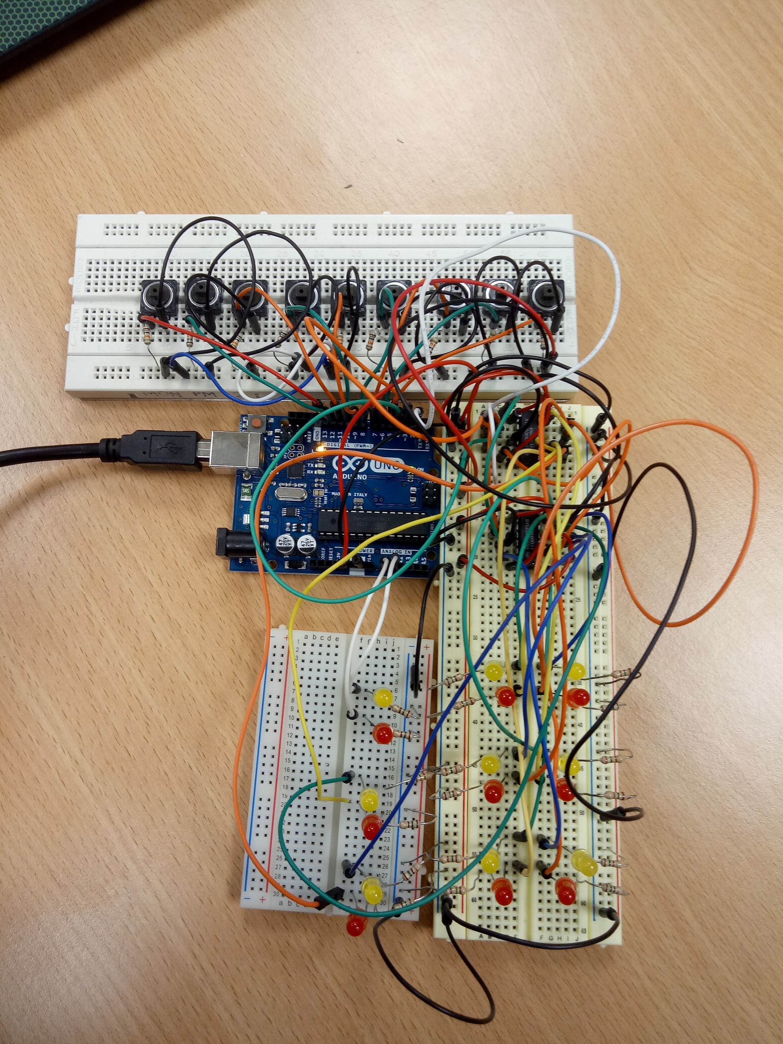

Although the implementation was a success, we decided that it was not feasible to control each individual LED since there is a large number of outputs in TetrIEMs unlike the tic-tac-toe. Thus, we have changed our approach to using rows and columns to control the matrix with two MAX7219 LED display drivers which we tested out using our prototype showed in the image below.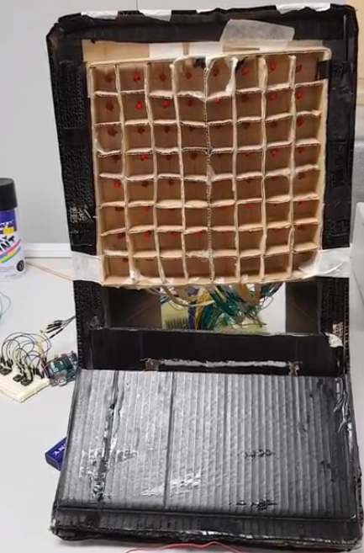

##### **3.2 General Structure (Hardware components)**

###### **3.2.1 Main Body (Plywood and Foam Matrix)**

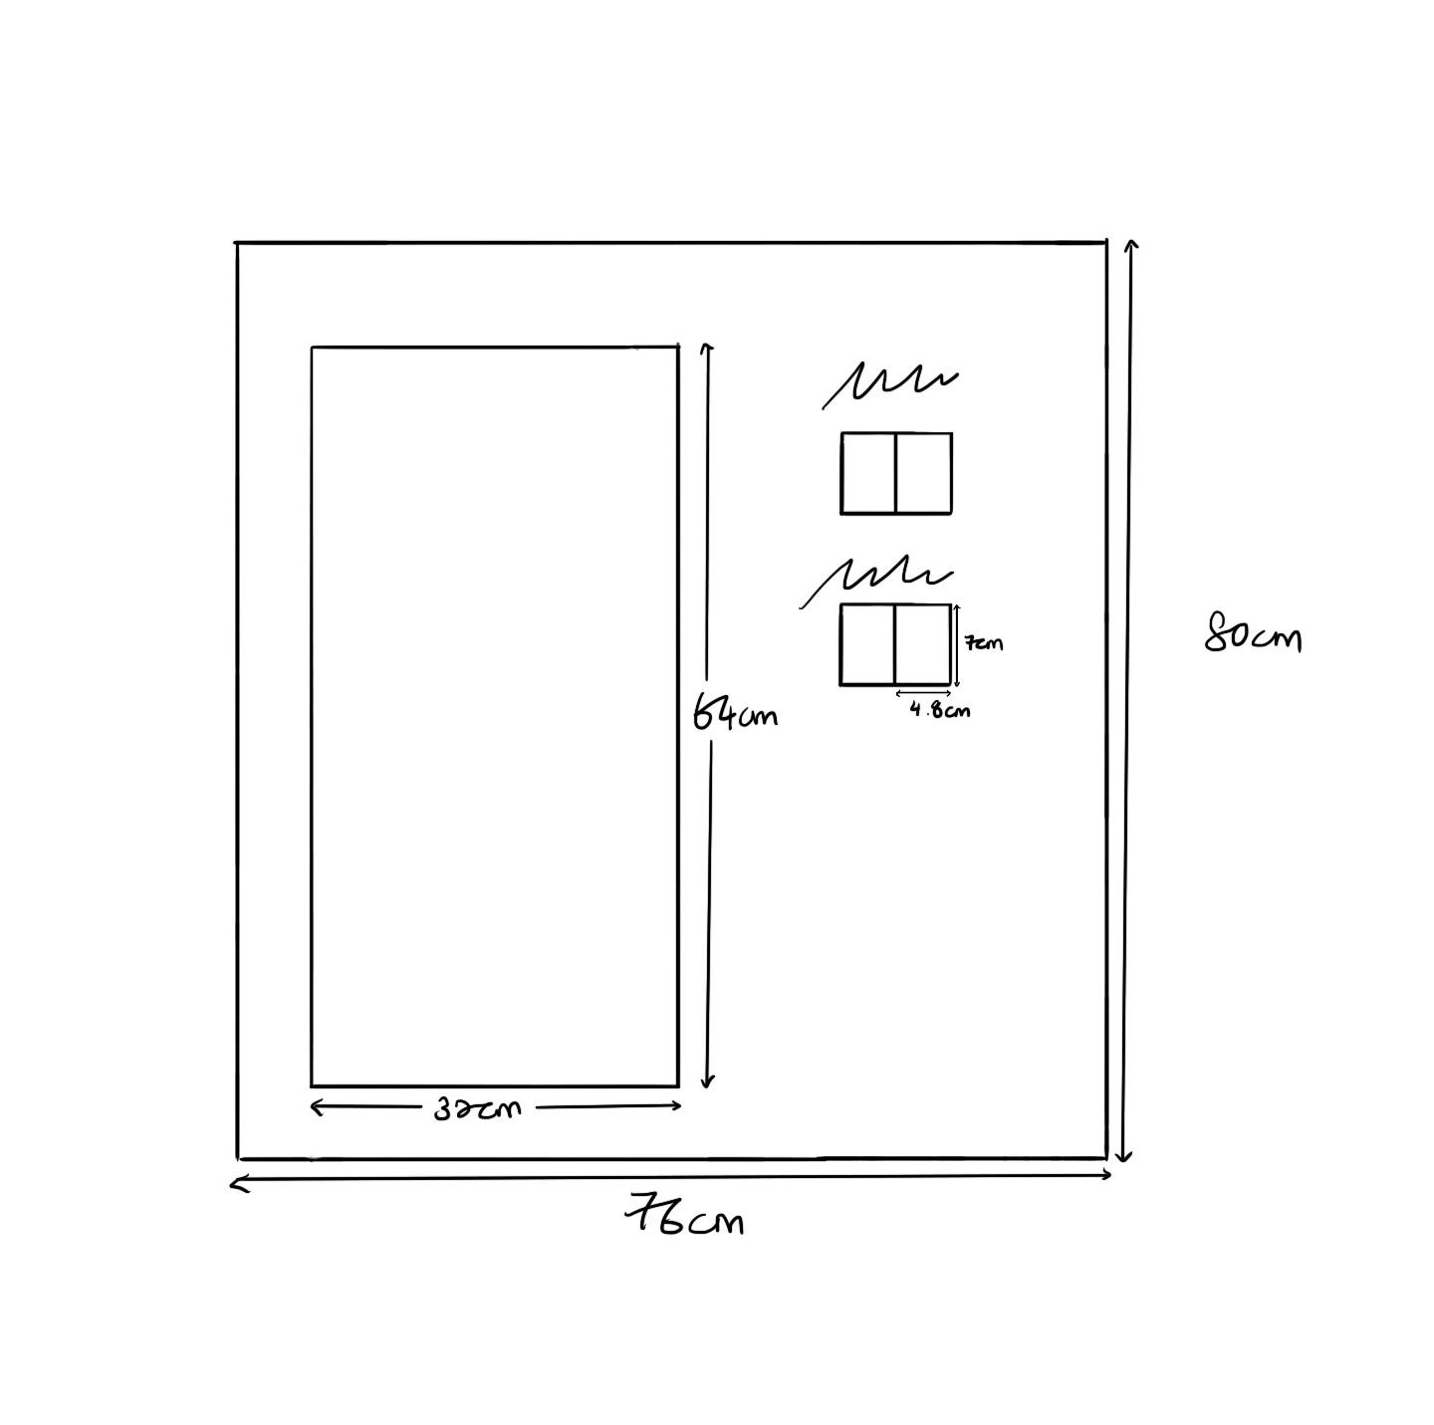

The components of our TetrIEMs is to be contained within a 76x80x15 box (details of dimensions under section 4.1), which consists of the LED matrix, Arduino Mega, 7-segment displays, and the wiring. The dimensions were specifically chosen to ensure that most of the wiring can be done inside the box, keeping them out of sight and reducing any potential safety hazards.

Another design consideration included a door at the back of the box. In the scenario where maintenance is needed, this provides easy access to the wiring and circuitry without having to dismantle everything.

The weight of the TetrIEMs was another important factor. During the planning phase, some possible ways of implementing our TetrIEMs was either to mount it on the wall or on the table, which requires the TetrIEMs to be lightweight.

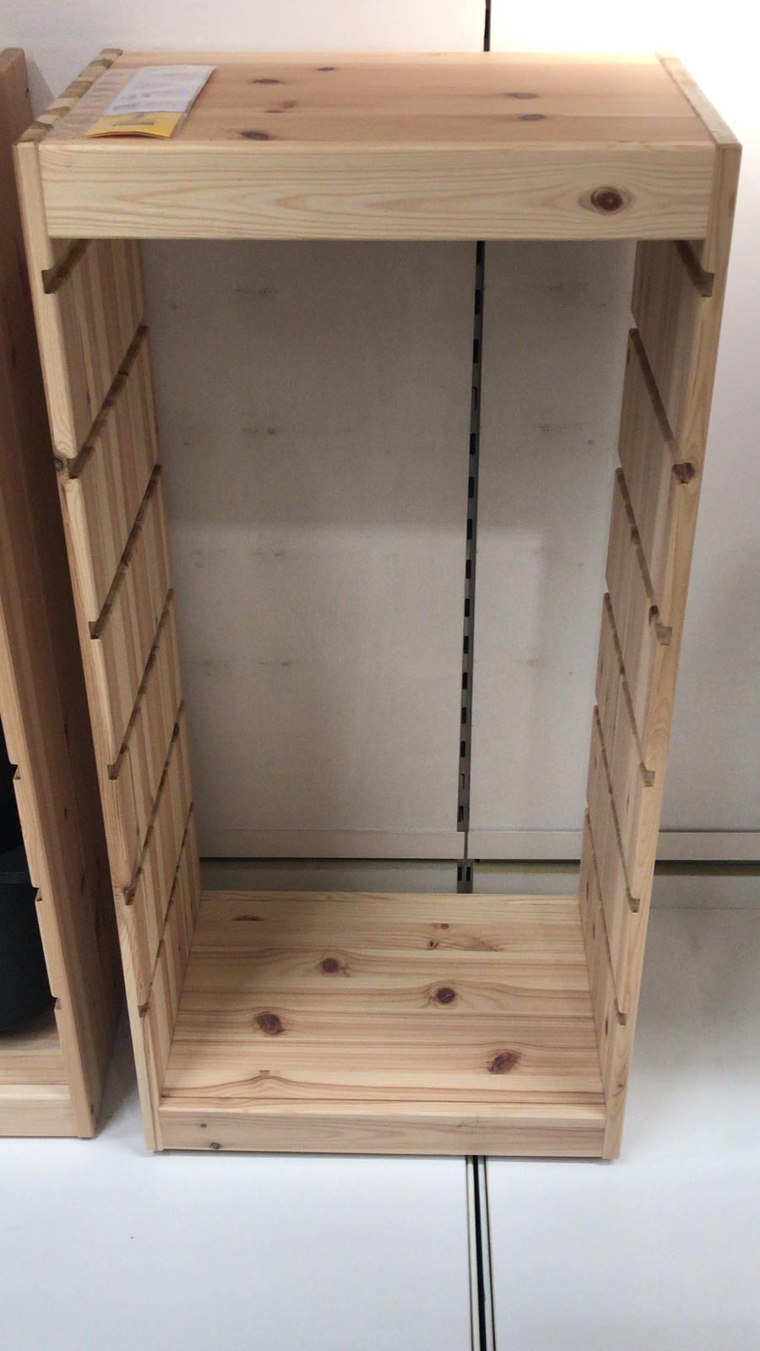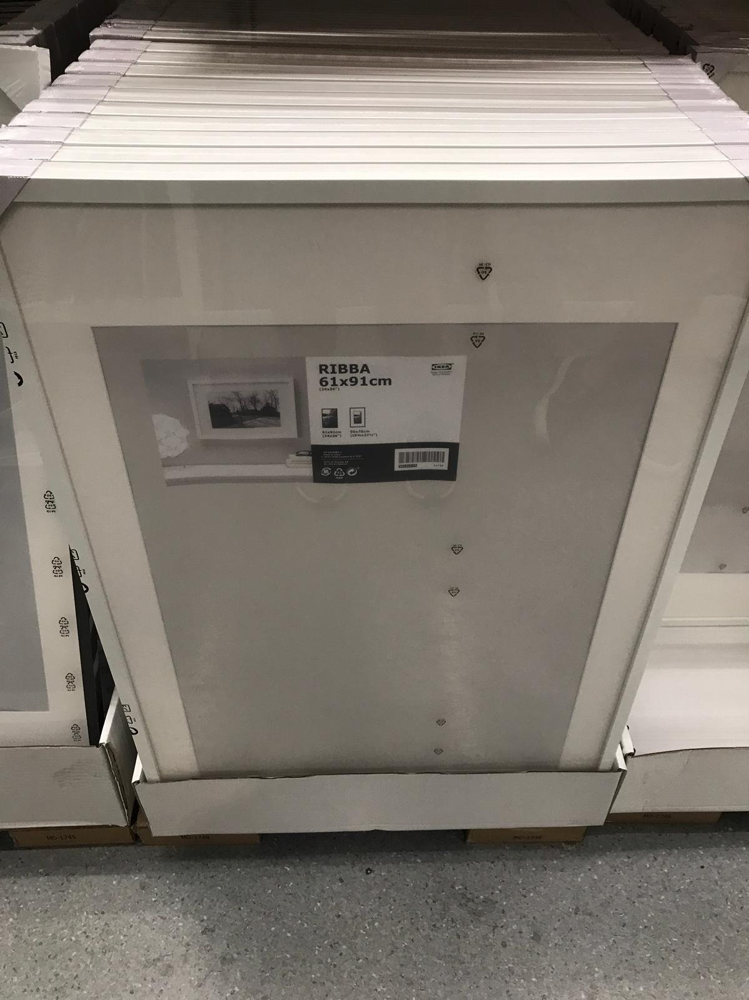

With these specifications in mind, we first tried to find ready made shelves that we can use. However, all the shelves we found were either too heavy or its size was unable to fulfill our design requirements. Aside from shelves, we also looked at other potential alternatives such as photo frames, the photo frames came close to the dimensions that we were looking at, however in order to achieve the optimal width, we required multiple frames to combine to form a cabinet-like shape.

Eventually, we successfully sourced for a plywood supplier and decided to build the matrix from scratch. We purchased 2 pieces of 2m by 2m by 5mm plywood to ensure that there was a balance between the weight and durability. Next, we proceeded to saw the wood to the sizes required which were 2 pieces of 76x80cm , 2 pieces of 80x15cm and 2 pieces of 76x15cm.

After completing the main body of TetrIEMs, the next component that we worked on was the 16x8 grid matrix. As our project was of a big scale, we are unable to buy a pre-made LED matrix. Thus, we decided to make our own matrix from scratch, the dimension for each grid in the matrix is 4cm by 4cm by 4cm. Considering that the matrix would be relatively large, we decided to use foam board to achieve a lighter matrix as a whole. The grid is made by cutting small openings on strips of foam, then connecting them together to complete the shape.

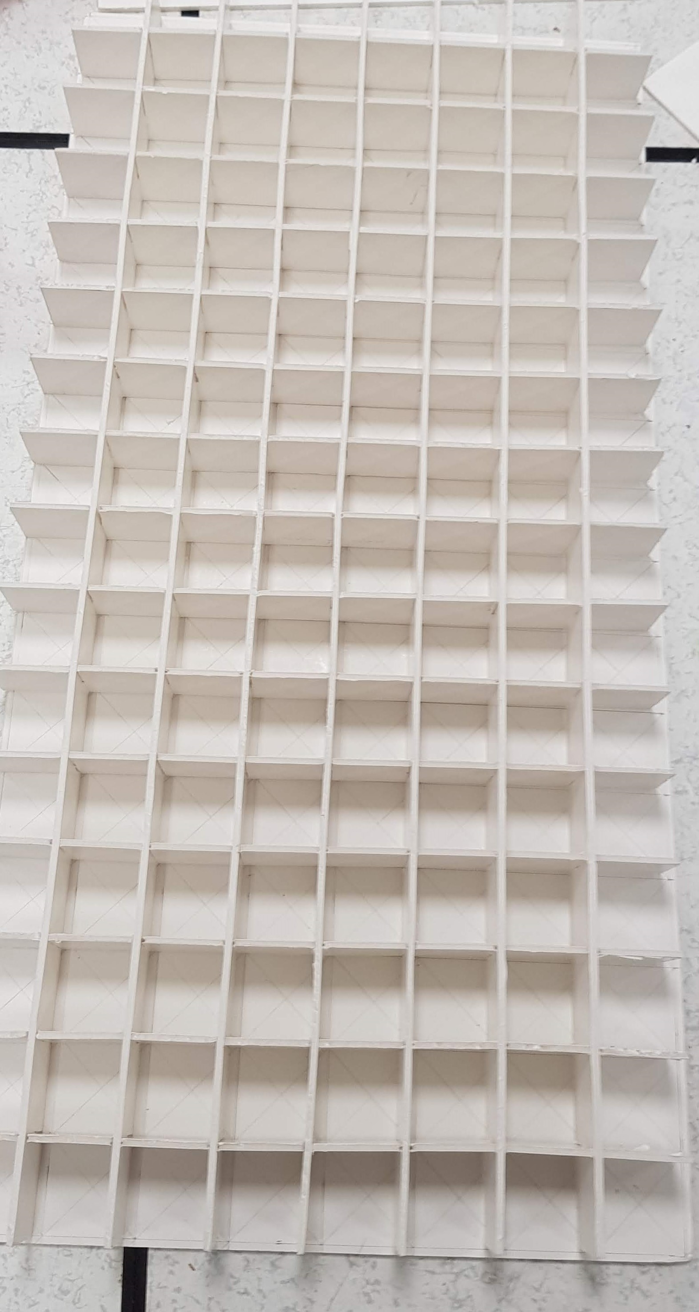

###### **3.2.2 Matrix (Transistors, wiring and breadboard connections)**

For our project, we need to light up a total of 128 (8x16) LEDs. However, the Arduino Uno or even the Mega does not have enough pins to control this many LEDs individually. After doing some research online, at first, we tried to use 74HC595s shift registers, but we could not find the suitable library online. Instead, we found that we can to use the MAX7219 which uses the ledControl.h library to control rows and columns of the LED Matrix.

The MAX7219 controls an 8x8 LED Matrix, and only requires 3 input pins from the Arduino (Data In, Clock and Chip Select). They can also be daisy chained, meaning we only need 3 pins in total to control our 16x8 LED Matrix, by daisy chaining two MAX7219 drivers together.

In order to construct the 16x8 LED matrix needed for Tetris, a total of 288 pin headers have to be soldered to a single PCB board. 256 pin headers are required for the 128 LED bulbs (each LED bulb has a positive and negative leg), and 32 pin headers for each row and column. It was important to ensure sufficient distance between each pin header in order to allow the wire soldered to the LED to be inserted with ease. This error occurred during the construction of the prototype. Our failure to consider the distance between pin headers caused increased difficulty and delay during the assembly of the prototype. Also, to avoid burning and damaging the PCB board, the soldering iron cannot be allowed to come into contact with the PCB board for too long.

After the pin headers are soldered, they have to be wire wrapped to connect the positive legs of all LEDs in a row, and the negative legs of all LED’s in a column. The last pin header in each row and column was then wire wrapped to a separate pin header for further connection. A 0.5mm wire wrapping wire and a standard wire-wrapping tool was used. Throughout this process, it is vital to ensure that the wires wrapped around each pin header do not overlap so as to ensure that there is sufficient exposed wire in contact with the pin header. Also, in order to prevent short circuits, it is imperative that the wires are stripped to a specific length so that there are no exposed wires from separate pin headers within close proximity of each other. This step is highly important, as it is exceedingly time consuming to remove a wire once it has been wrapped. It is also crucial to check that every single pin header has been wire wrapped and connected to the adjacent pin header just in case certain pin headers were neglected. When dealing with 288 individual pin headers, this can easily occur.

Next, wires have to be soldered to the individual LED bulbs. We have to ensure that the wires used are of sufficient length to allow it to be comfortably mounted on the wooden frame. Thus, we overestimated the length of wire required to allow for any modification in the set up. After trying out several different methods of soldering the wire onto the LED leg, we concluded that the most efficient method was to solder while both the wire and the LED leg was taped down. This prevents the wire and LED leg from moving and allows the solder to cool without much complication. After soldering, the LED’s were tested individually to ensure that they are in working condition before being connected to the PCB board.

Due to the large amount of wires (a total of 256), we used masking tape to organise the wires so it is easier to find the wires that we need.

###### **3.2.3 7-Segment Display**

At first, we considered using LCD displays, but they were too small and since we only needed to display digits, we decided to use 7-segment displays.

Four pieces of 7-segments are used to display the tiles and score. During the testing phase, we realised that the Arduino Mega I/O pins were not able to supply enough voltage to the 7-segment pins, which requires about 7V. Hence, an external 9V cell is required to power the 7-segments. With transistors connected to the Arduino I/O pins instead, we can still control each individual segment using the Arduino.

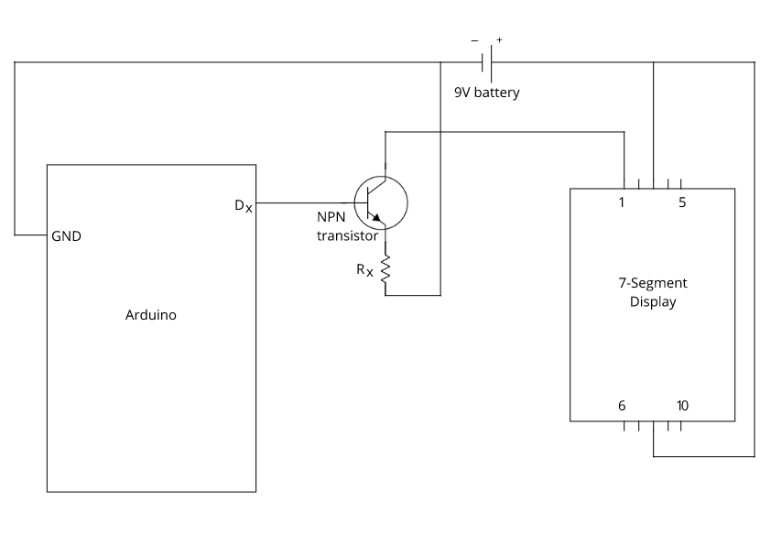

The diagram above shows how one segment is controlled by the Arduino and powered by the 9V battery. Pins 3 and 8 are connected to VCC, pin 10 is unused as it is for the decimal point. The remaining seven pins are each connected to the collector of individual transistors, with the base connected to individual Arduino pins.

###### **3.2.4 Drum Kit (Piezo Sensor)**

Our group experimented with several types of sensors and methods in order to created a new interactive gameplay such as using motion sensors and light sensors. Our drum kit idea stemmed from looking at popular arcade games and we wanted to incorporate the games that had a higher level of fun and it seemed like games that include hitting something seemed the most popular such as the drumming games. Thus, we decided to use piezo sensors instead to incorporate with our drum kit idea as it seemed the most feasible and inexpensive method. The sensitivity of the piezos were not consistent so we had to factor that into account in our codes by adjusting the threshold values for each piezo. The drum materials were also an important factor because if it is not sturdy, hitting the drum too hard might break it and if it is too thick, the piezos would not be able to detect the knock, thus failing to register the step made.

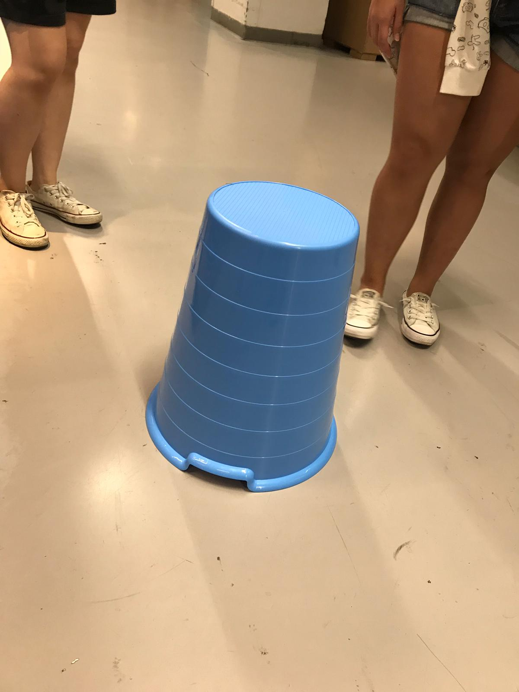

##### **3.3 Arduino Codes (Using Arduino Mega)**

For the tetris game code, there are seven types of blocks (“Square”, ”L”, ”J”, ”T”, ”I”, ”Z”, ”S”), three control sensors (piezo sensors for left, right and rotate), one button (start/restart), four 7-segment displays (two for tiles and two for score) that we needed to code for. Initially, we planned to control two 7-segment displays together (for two-digit numbers) but the library did not support our configuration (with transistors). Thus, we decided to control each segment individually. The detailed codes are found in Appendix D.

#### **4. Design and Implementation**

##### **4.1 Aesthetic Design**

For our project design, we went through many iterations of it.

The first version being a huge display made out of individual LEDs at the top of the game display, giving both the ‘score’ and ‘timer’ with 3 digits each. It was intended to be 100 cm by a 100 cm and is playable by 4 big 5 cm in diameter buttons at the bottom of the game display. The buttons would be left, right, rotate and a pause button.

The game display will be filled with individual LEDs and the materials we were considering consisted of foam board, plywood and an acrylic sheet cover over the entire body to protect the LEDs. These were planned in mind to keep the entire body light so it could be hung on the wall and we stuck with the same materials throughout the iterations.

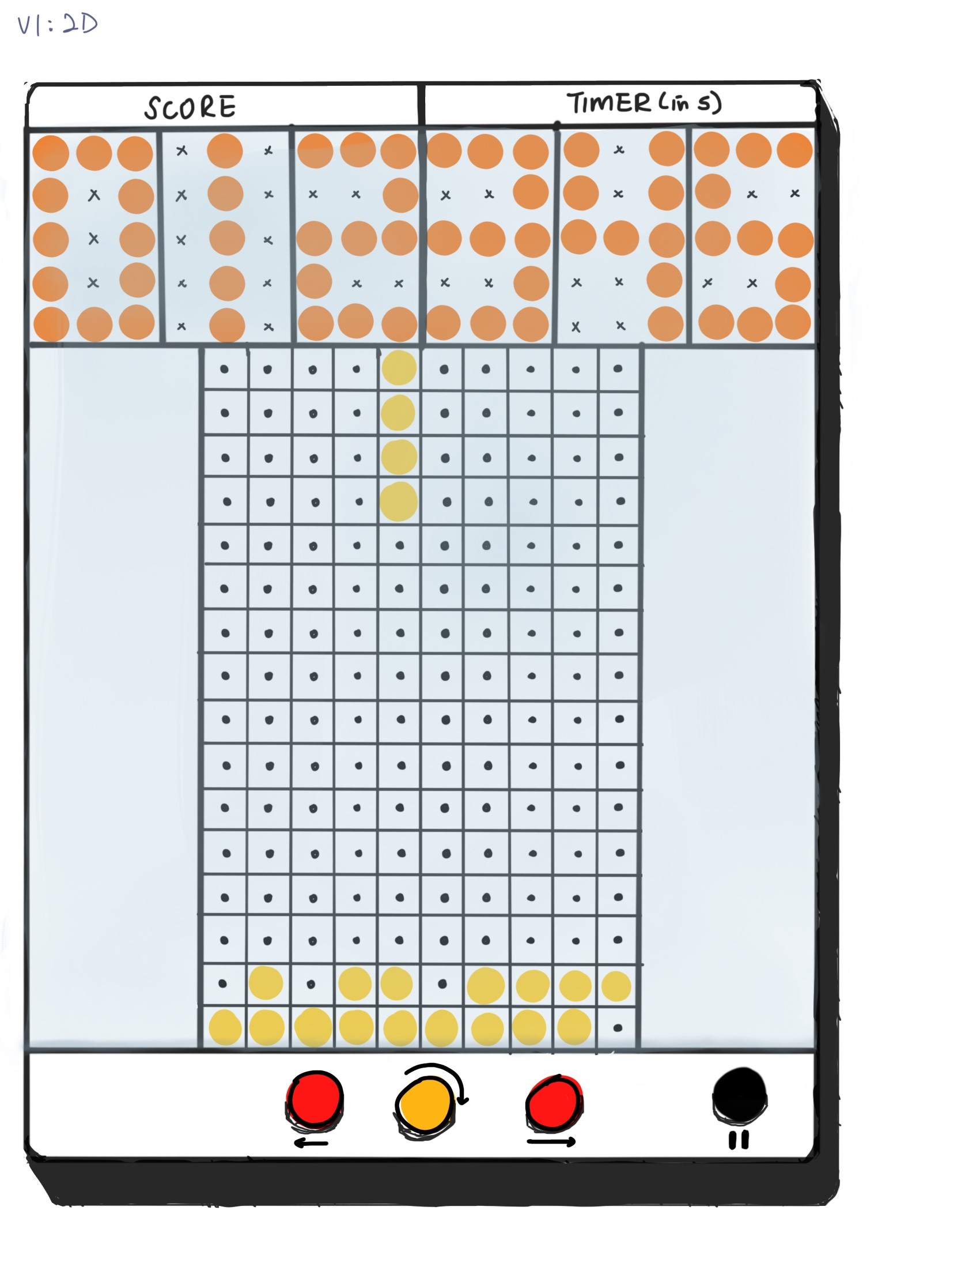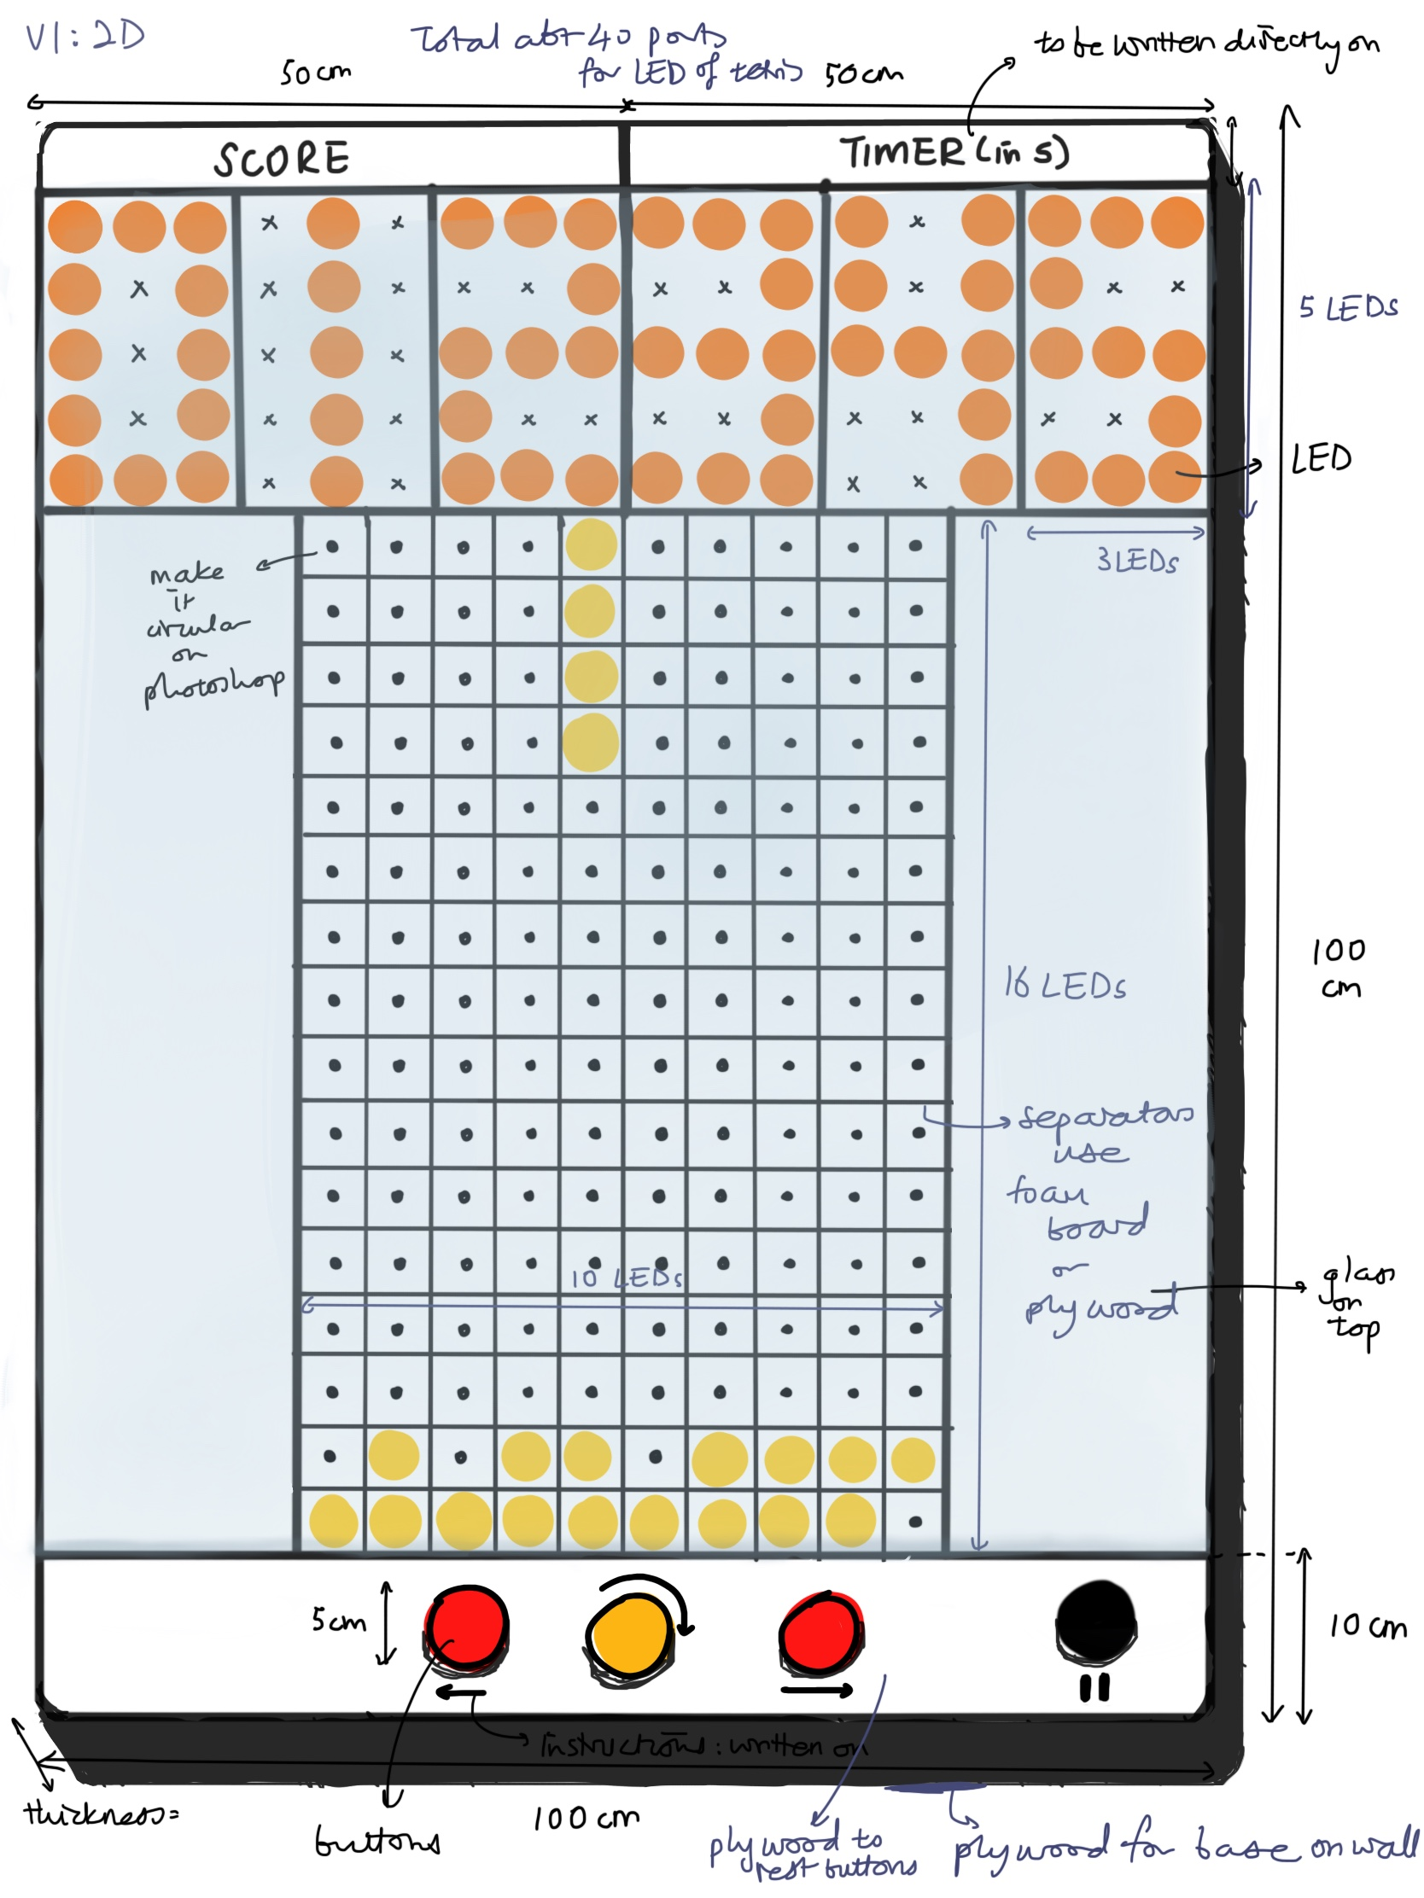

For our second iteration, we kept it simple and decided not to use as much connections on the Arduino board and so we cut down the numbered displays to only have a ‘tilesr’ and the score will only be displayed after the game was over.

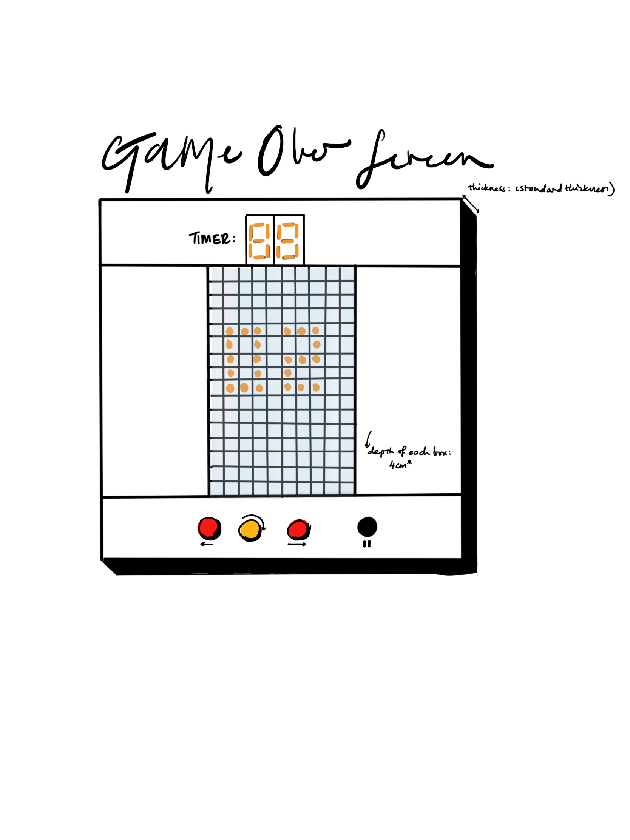

We eventually settled for something similar like in the next iteration, when we decided to use 7 segment displays instead for the ‘score’ and ‘timer’, providing 2 digits for both of them. Both are still positioned at the top but did not occupy as much space as before.

The measurements became 100 cm x 82 cm instead.

We were still considering buttons, but for the final design and execution, we went with something more interactive and unique - drums in place of buttons.

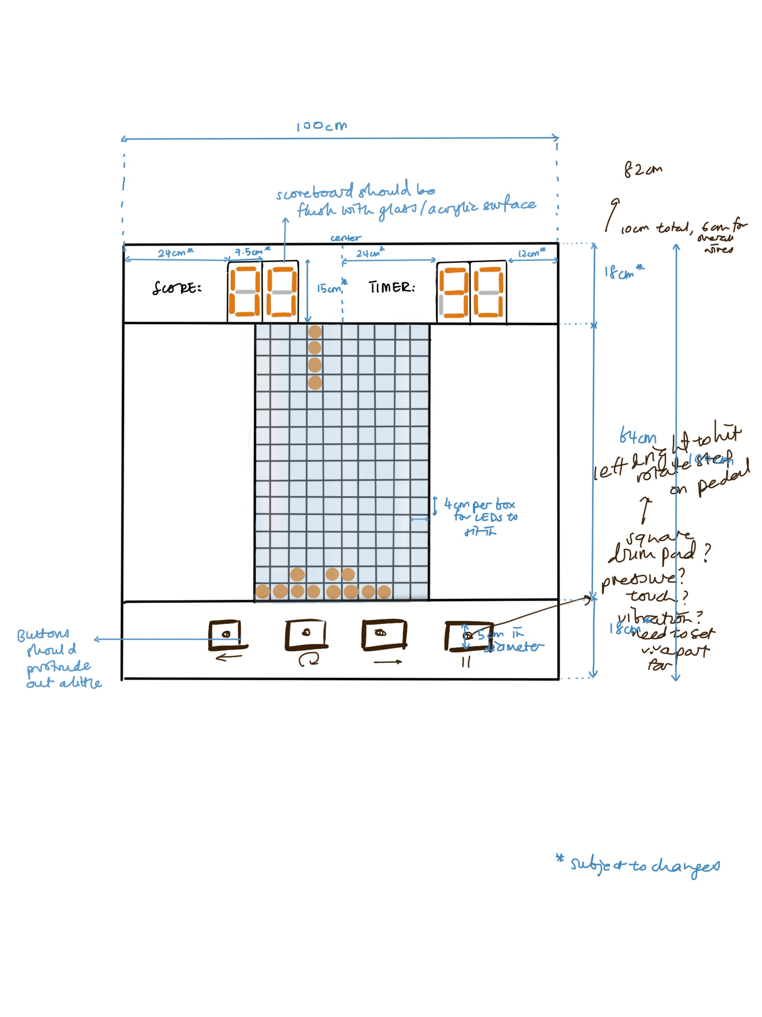

However, even with the considerably light materials, there was still the issue of the overall weight since it was supposed to be hung on a wall. We eventually decided to minimise the size of the design by reducing the size of it, resulting in a 76 cm by 80 cm board.

We also decided to attach all the boards (like the Arduino Mega) and wires behind and by the sides of the LEDs as indicated in the right image.

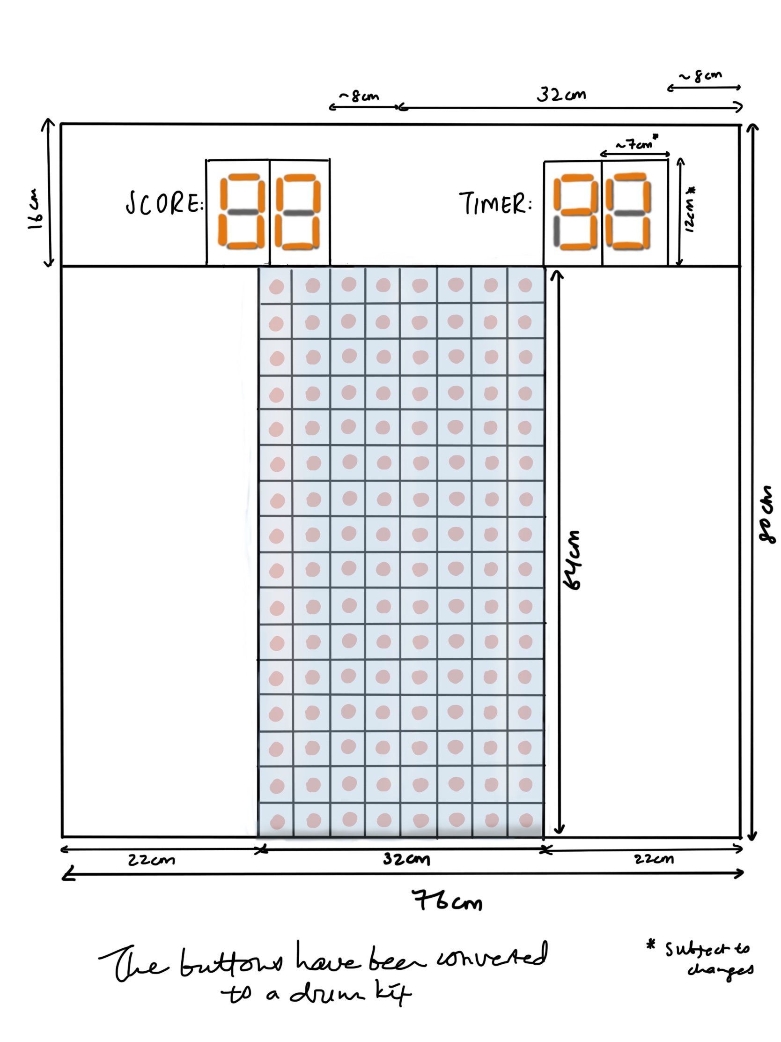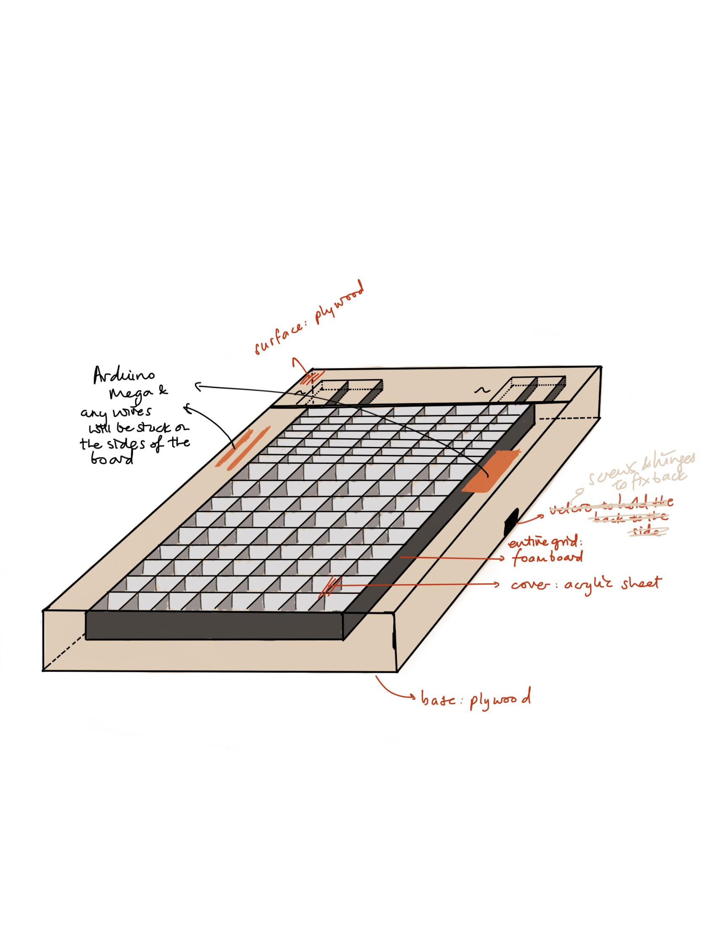

For the drums, we went with some IKEA stools that were tall enough for us to hit comfortably while being seated. There were 3 bins for left, right and fastforward and a pedal for rotating pieces.

We intend to use piezo pressure sensors to detect any hits on the drums, wrapping the sensors onto the bins with elastic balloons to hide the sensors.

The variations of the drums are still subjected to change at this point and will eventually be left, rotate and right instead.

We then built the life-size mock-up with scrap materials such as cardboard, egg cartons, paper and plastic covers to give us a look and feel of how big the entire board will be.

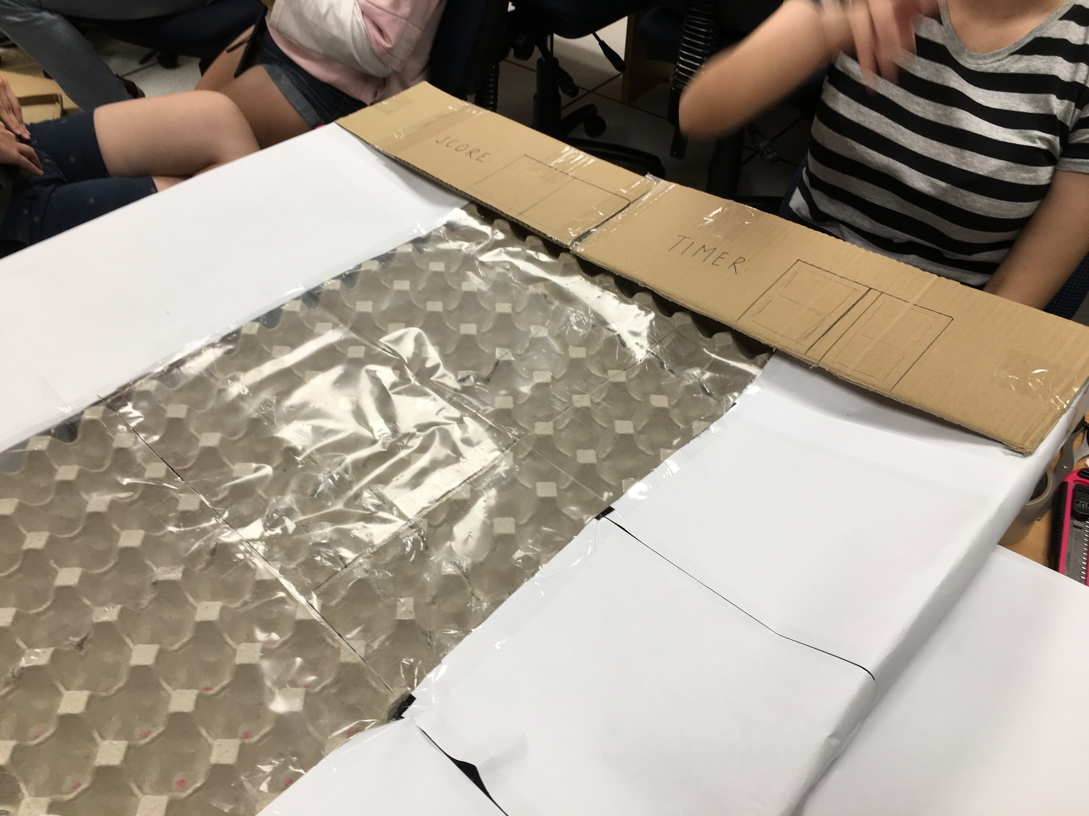

With this, we decided that the tiles and score boards will cause the whole design to be too long for its height compared to its breadth. There was also too much empty space by the sides of the game board.

Thus we decide to shift the timer and score to the right side of the LED matrix which is also similar to many retro game consoles.

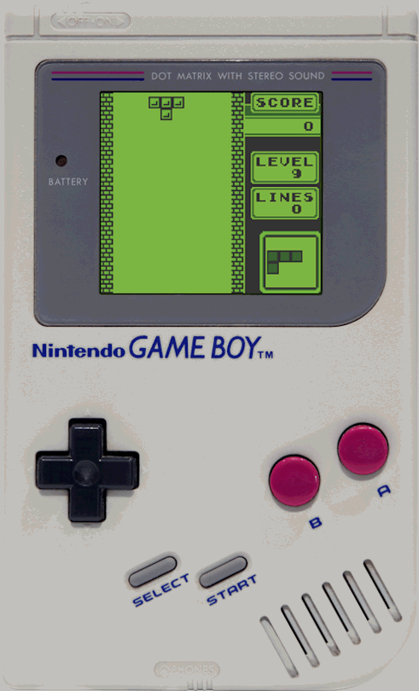

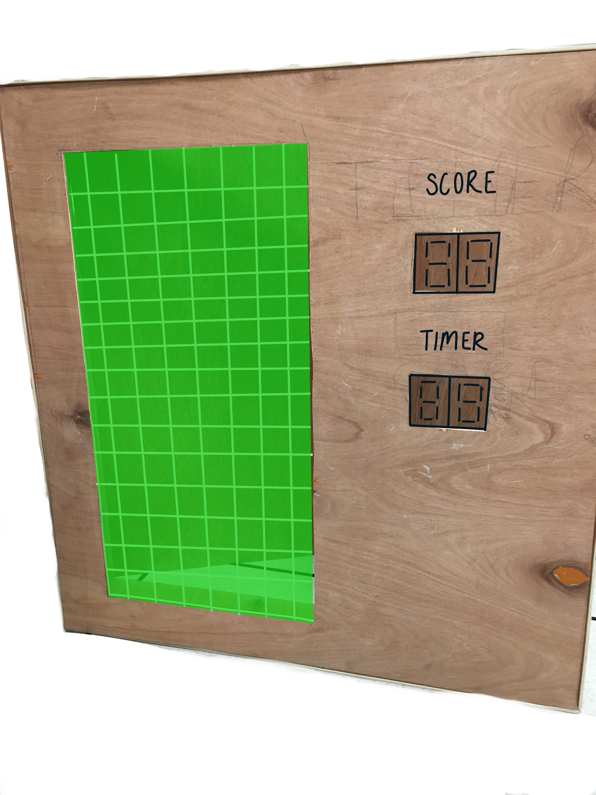

For our design on the board, we first approached the idea of having an obvious design of a classic tetris game by having tetris tiles filled up around the board. However, after considering that the design is too complicated and it can instead cause it to be distracting, we decided to change it.

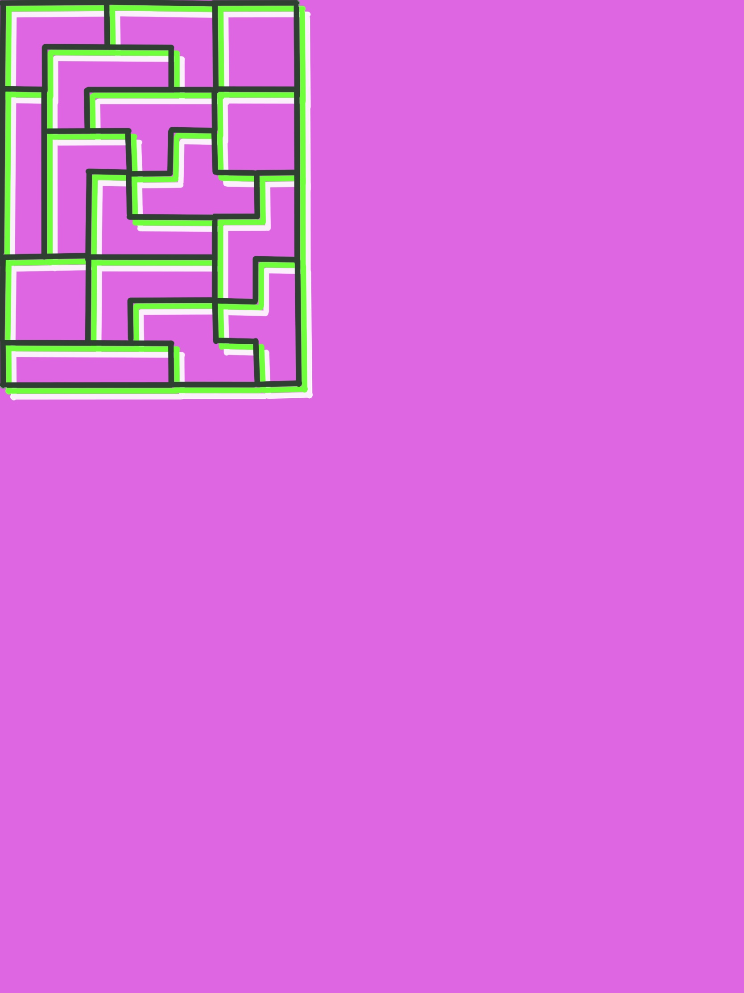

Hence, we decided to keep it simple and have our design that is inspired by retro tetris game consoles.

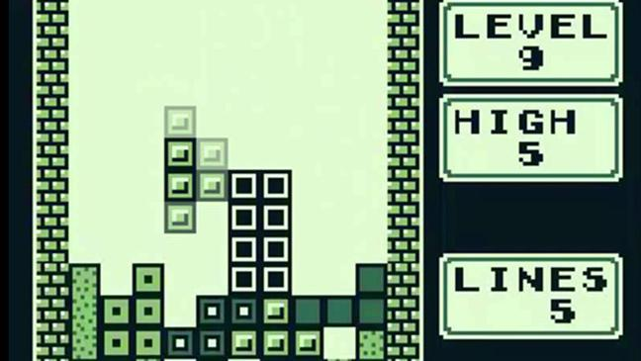

Shown below is the design along with an application with the drum kit.

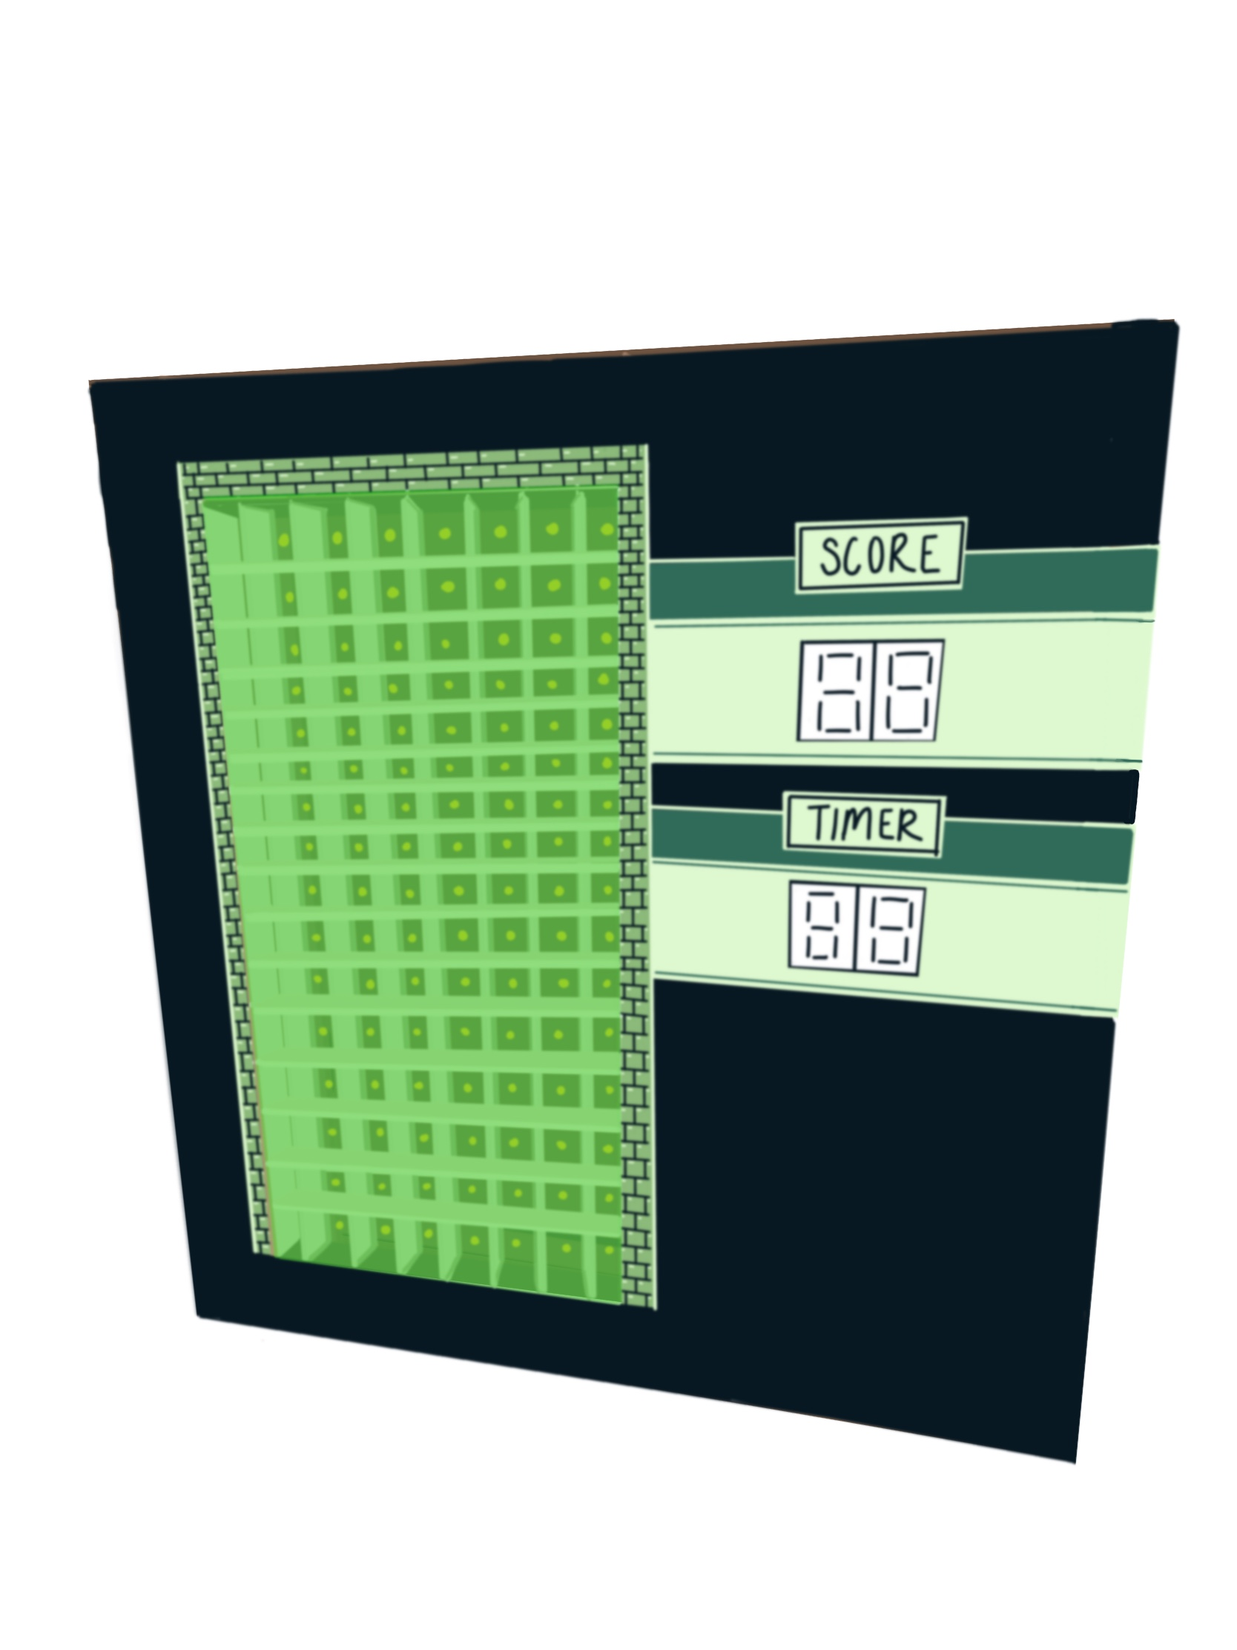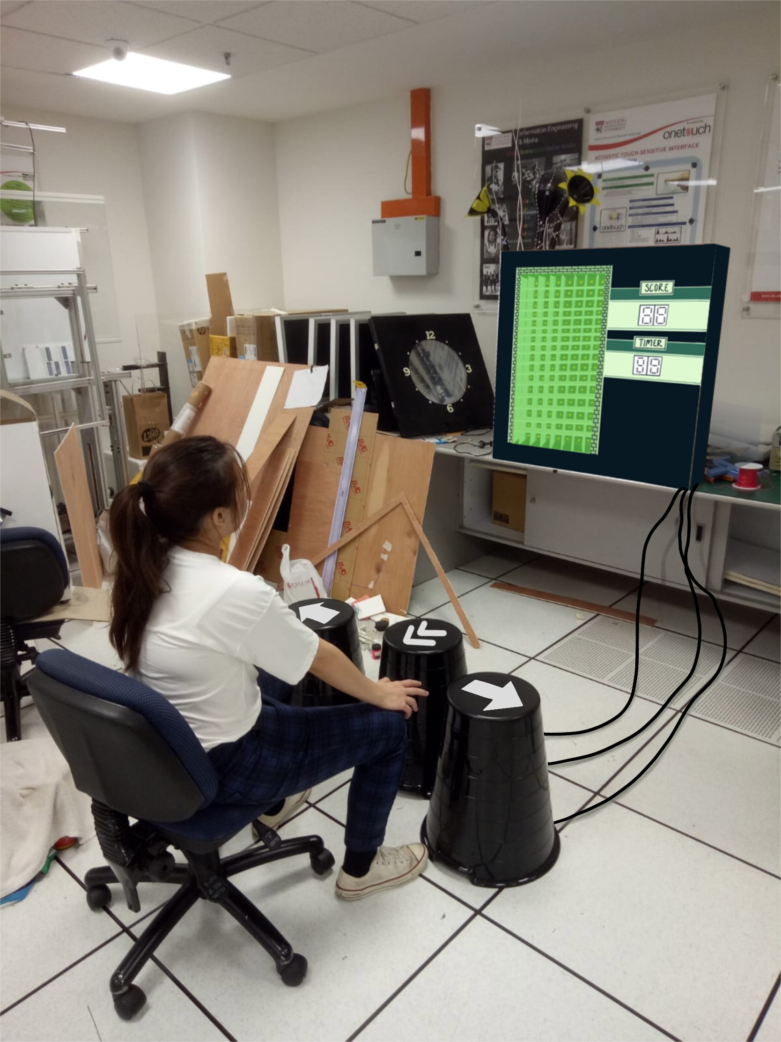

Furthermore to add a bit of twist, we added a pixelated green dinosaur at a corner of the design. Since dinosaurs are ancient animals, similar to the classic Tetris game with a long history, we found the imagery befitting.

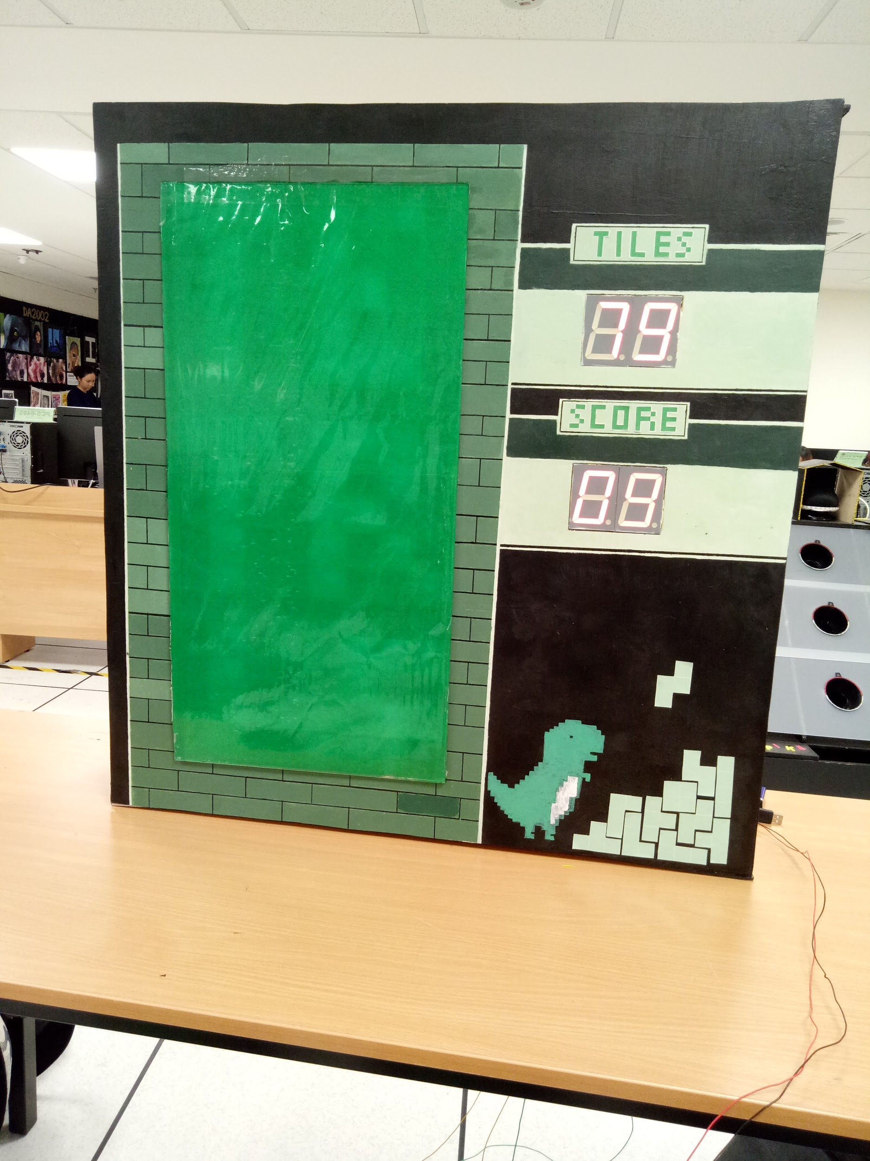

As for the backdoor, it is a heart made up of green tetris tiles which forms “I love IEM” surrounded with our members’ signatures to give our IEM originality and personality.

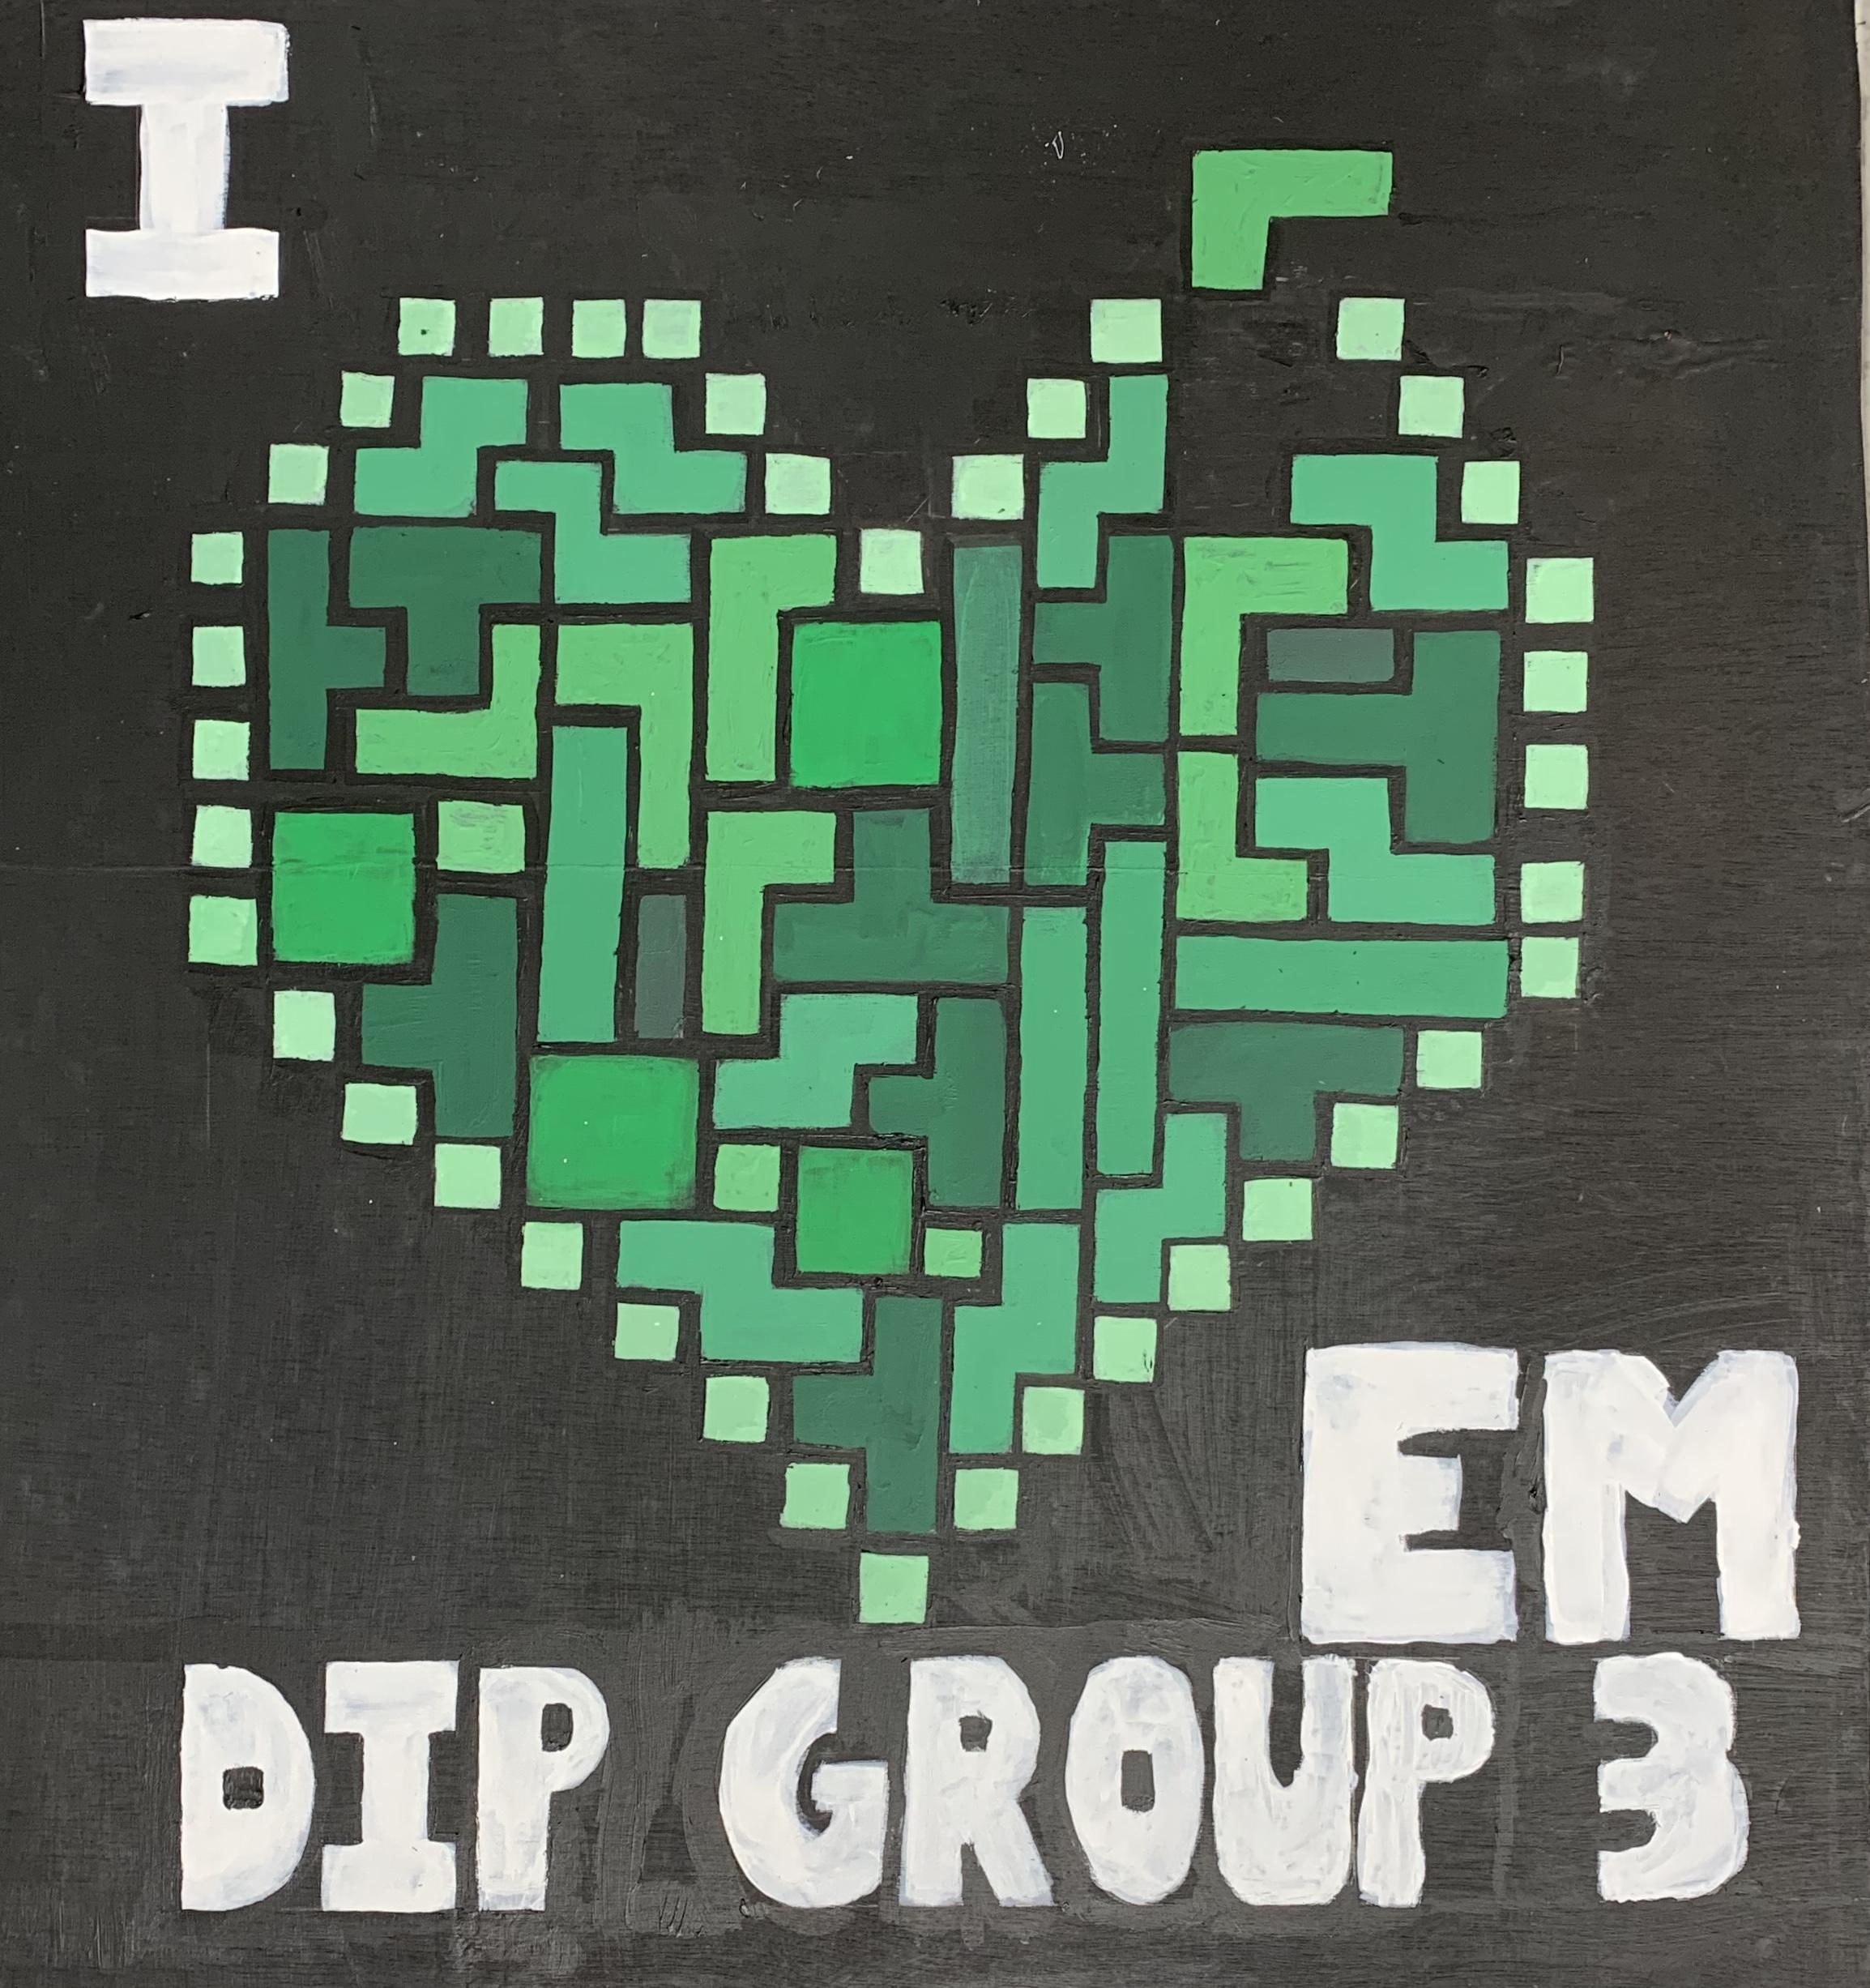

##### **4.2 IC Design**

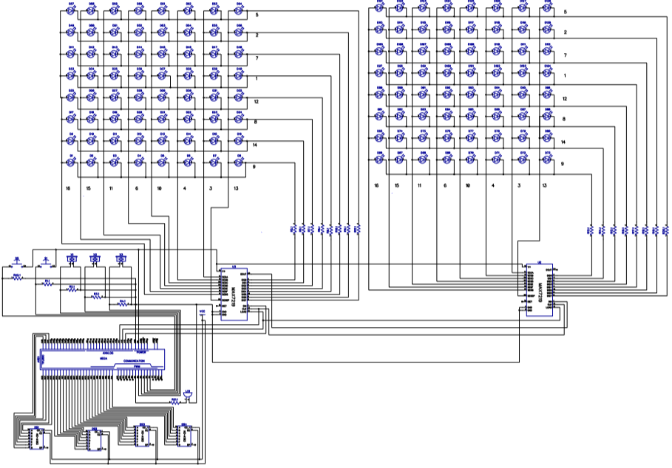

The software our group used for our IC Designing is DipTrace. DipTrace is an Electronic Design Automation (*EDA*)/Computer-Aided Design (CAD) software designed to create schematic diagrams and printed circuit boards. It comes well equipped with a multilingual interface as well as tutorials.

Whilst searching for the optimal program to use, we tried out software such as Kicad and EasyEDA. However, there are a few features lacking in both of these that made DipTrace stand out.

Both Kicad and EasyEDA are lacking in the number of schematic import types supported. Hence, PCB designs done on different applications will require some modifications. EasyEDA also lacks a 3D viewer, an important feature in visualising how the Printed Circuit Board (PCB) looks like when fully assembled with components of varying heights. Another non-user friendly problem faced is the cumbersome keystroke mechanics of EasyEDA. During the initial launch of EasyEDA, the view is zoomed all the way out and manual centering and zooming in has to be done. Also, when zooming in or out, the grid does not re-scale accordingly.

Kicad is old-school looking with no labeling so it takes some time to get used to. It also doesn’t have a default list of components, so self designing or online searching is required.

DipTrace solves these problems with its ability to import a myriad of schematics and filter different components for easy searching.

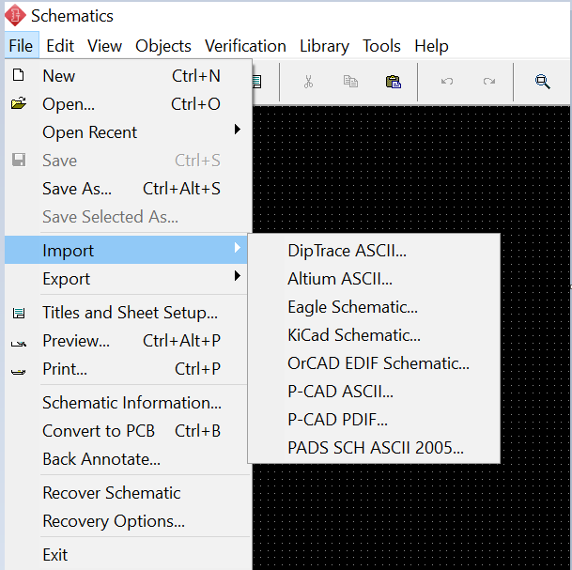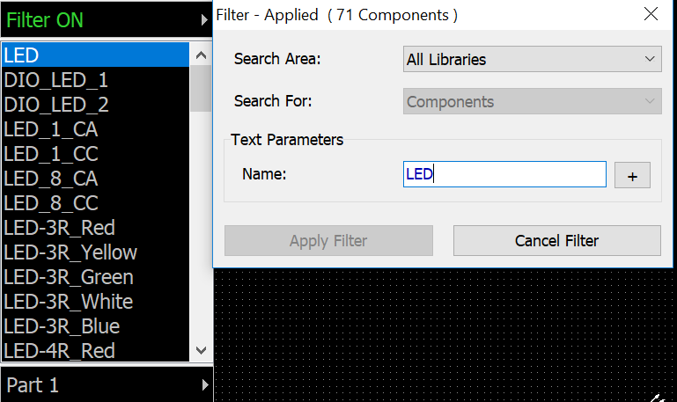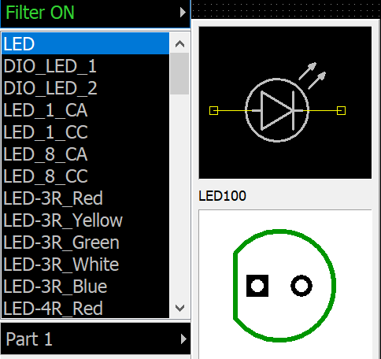

It is more modern looking with large libraries of default components available and includes labeling, save for the main bar at the top.

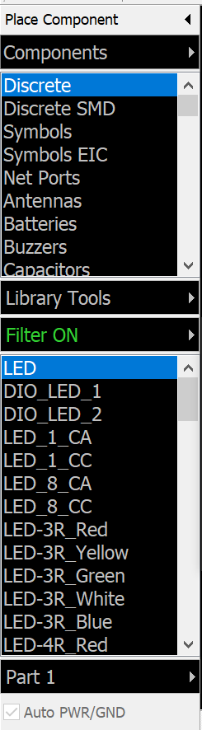

These are critical as creating new components on our own may introduce errors that would not be captured by any of the verification tools if not done properly. DipTrace consists of four separate modules. One for schematic entry, one for PCB layout, one for creating new components, and one for creating new PCB landing patterns. The main option we used is the schematic capture in order to professionally showcase our IC design.

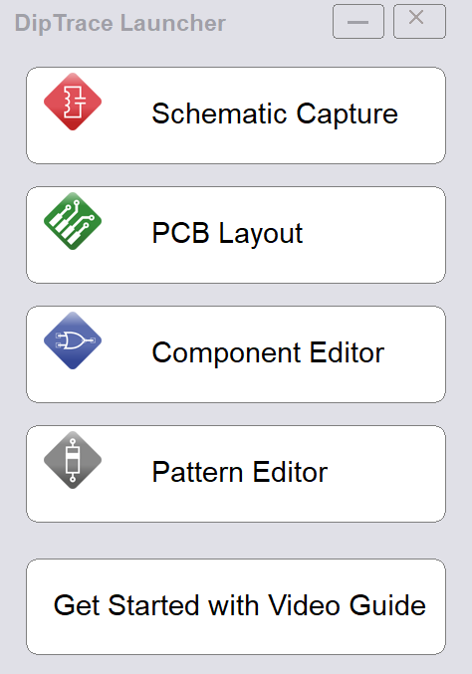

DipTrace also has a dedicated forum where users discuss their problems faced and share components that might not be available in DipTrace otherwise. An example of its useful nature was obtaining the component design and pin layout of Arduino Mega through the forum.

A downside to DipTrace is that the free version only allows up to 300 pins to be connected. In order to utilise over that limit, a registration key is required. Fortunately, a free trial of the full version lasting 30 days can be installed instead, and we installed it on two computers to allow us enough time to complete our design.

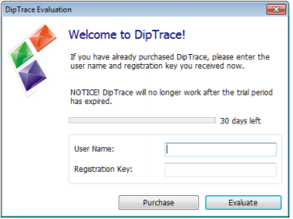

The figure below shows our Schematic Design for TetrIEMs. It can be segregated into two parts. First, the connections from MAX7219 to two sets of LEDs (8 row and 8 columns each) through resistors as shown below. This is for controlling the movements of the lighting up of the LEDs .

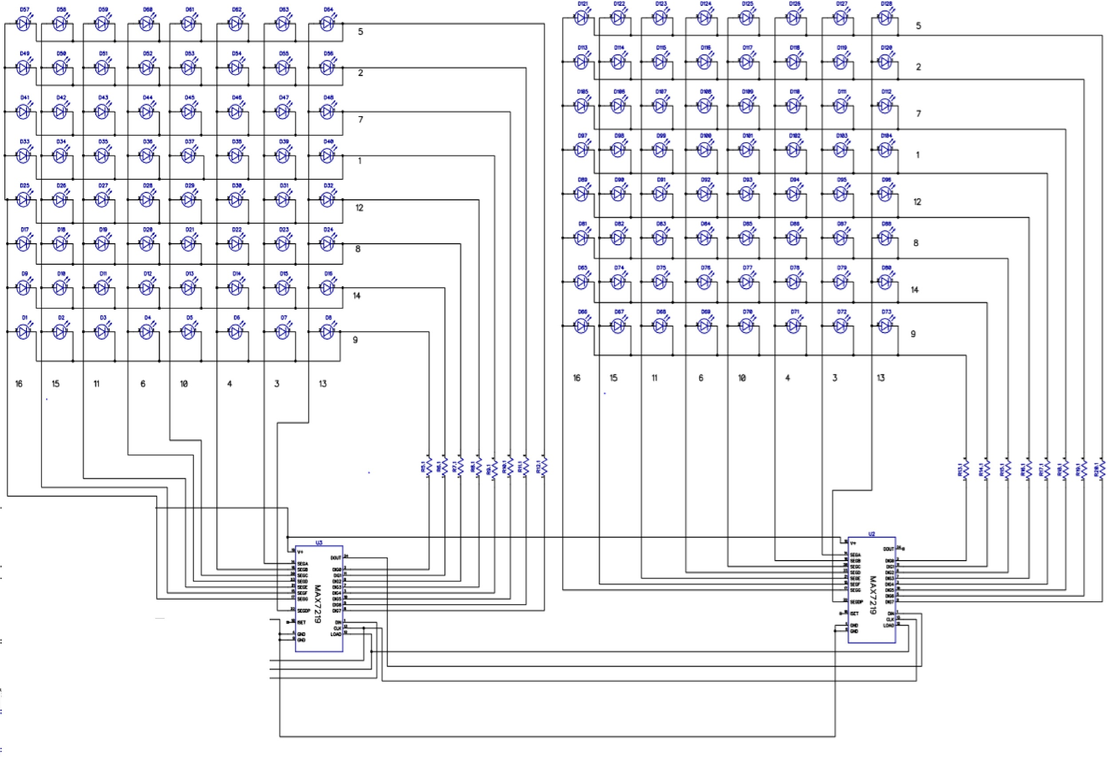

The other half of the schematics is on the connections of the Arduino Mega, Buzzer, Piezo sensors and 7-segments. These are for the sounding of the buzzer, controlling of the LED tetris blocks and displaying of scores respectively.

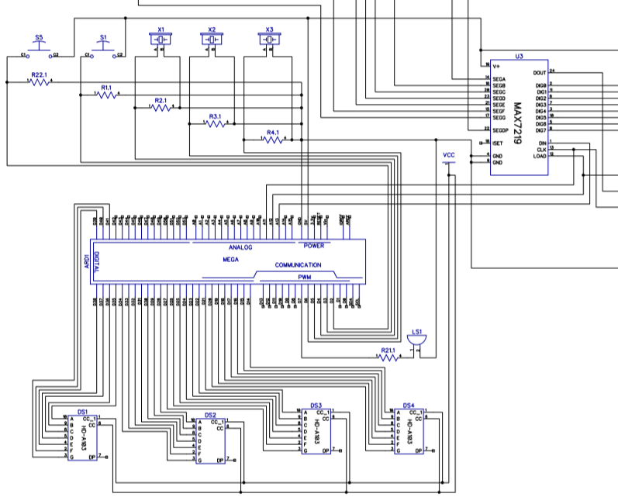

The pin connections are all found online and connected synonymously according to the coding of our tetris game. Our entire Schematic Design in DIPTrace is shown below.

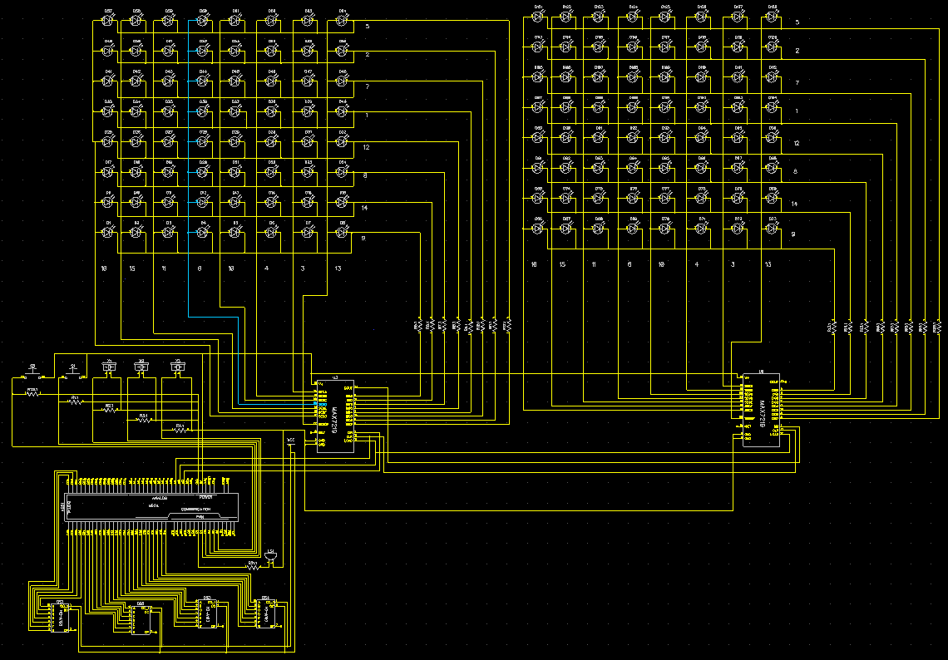

Some schematic information of our IC Design : 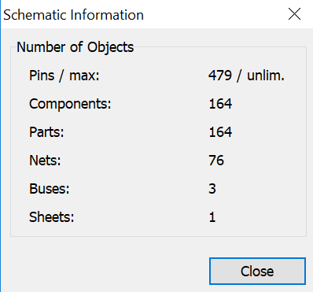

##### **4.3 Implementation of TetrIEMs**

After 14 weeks of hardwork of piecing together the hardware structure and software codes, TetrIEMs is fully operational after all the planning we have done mentioned in the previous sections.The details of How-to-Play and Set-Up are under the Appendices B and C.

#### **5. Conclusion and Recommendation**

##### **5.1 Conclusion**

Overall, we are satisfied with our project as it is both functional and fun. We hope that our efforts into building this would bring entertainment to the user as well as make them think about how much hard work it actually takes to build a larger scale project.

##### **5.2 Recommendation for Future Works**

Our group have several suggestions and improvements to propose:

1. Soldering row and column directly with one wire instead of individual wires
2. A detailed How-To-Guide tutorials for creating basic game coding for anybody who would like to use our structure to code new games.

#### **Appendices**

##### **A. Bill of Materials (BOM)**

Total Expenditure: $632.45

Expenditure for prototype: $133.49

Expenditure Breakdown:

|  |  |  |
| --- | --- | --- |
| **Item** | **Location** | **Price($)** |
| Divider | Daiso | 2 |
| Acrylic Sheet 18x24in | Artfriend | 9.95 |
| Green Cellophane | 2.2 |
| Glue Stick | 2.45 |
| Acrylic Sheet 36x24in | 16 |
| Foamboard x2 | 13.49 |
| Wood Primer | 12.9 |
| Painting Materials | 88.08 |
| Wood glue | 4.01 |
| 3M Hanger x3 | 18.63 |
| MDP Cardboard x2 | 10.78 |
| Balloons | Spotlight | 5.99 |
| LEDs x 200 | SimLim | 80 |
| Arduino Mega | 39 |
| PIR Sensor x2 | 16 |
| Matrix Module (Max) | 10 |
| 7 segment x 5 | 39.5 |
| Pin Header x 18 | 54 |
| MAX 7219 | 8.8 |
| Wrapping Wire | 20 |
| 4 Piezo Wafer Plate | 6 |
| 2 Piezo Knock Sensor | 5 |
| 9V Conn DC Plug | 1.5 |
| 9V Battery | 4.2 |
| 1 DC-Adpt (12V-2A) | 15 |
| 3 9V Conn DC Plug | 4.5 |
| MAX7219 | 6 |
| Piezo Plate x6 | 9 |
| 9V Conn DC Plug | 1.5 |
| 9V Alkaline Battery | 4.2 |
| 595 Shift Register x10 | 10 |
| MB-102-JX Breadboard |  | 6 |
| 9V Alkaline Battery x3 |  | 12.6 |
| PCB Mt Buzzer 3-12V x2 |  | 5 |
| Buzzer 3-12V |  | 2.5 |
| Piezo Plate x3 |  | 4.5 |
| Pin Female to Female 10C J |  | 2.6 |
| Plywood 5mmx4x8ft x2 | Buildmate (S) | 27.82 |
| Acrylic Hybrid Ruler | Popular | 7.35 |
| SS030 S/S HINGE x2 | Home Fix | 11.8 |
| Black Stool x3 | IKEA | 17.7 |
| Aluminium Foil | NTUC | 4.9 |
| Art Supplies + CD | Popular | 9 |

##### **B. Maintenance Guide**

Three 9V Batteries are required to power up TetrIEMs.

Do not let water into the main circuit board.

Do not shake the body violently.

Best used in a safe environment.

Please be gentle, I am fragile

##### **C. How-To Guides**

How to Play:

1. Switch on the power.
2. Start the game by pressing the Start Button.
3. Hit the drums in order to control the blocks. (i.e. Hitting drum with left arrow will trigger the block to move to the left)
4. Number of tiles indicate how many more tiles are left to clear.
5. Game ends when either finished tiles or game over.

Rules of the Tetris Game:

1. Shapes called Tetriminos fall from the top of the Matrix and come to rest at the bottom. Only one Tetrimino falls at a time.
2. By hitting the drum kit controls, you can adjust where and how the Tetriminos fall. By hitting the LEFT and RIGHT Arrow drums, you can slide the falling Tetrimino from side to side. You cannot slide a Tetrimino past the edge of the Matrix. By hitting the ROTATIONAL Arrow drum, you can rotate the Tetrimino 90 degrees clockwise.
3. The number of tiles indicate how many mores Tetriminos you must clear in order to get to the next level.

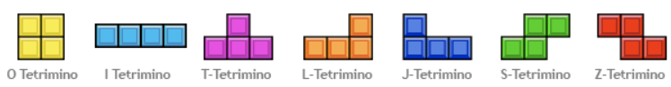

##### **D. Source Code**

Using Arduino IDE:

#include "LedControl.h"

//#include "SevenSeg.h"

//==============================================================================

LedControl lc=LedControl(13,11,12,2);//Pin: Data in , clk , cs , ledControl

//SevenSeg disp(14,15,16,17,18,19,20);//Defines the segment A-G;

//SevenSeg disp_score(22,24,26,28,30,32,34);

const int number[11] = {0b1000000, 0b1111001, 0b0100100, 0b0110000, 0b0011001, 0b0010010, 0b0000010, 0b1111000, 0b0000000, 0b0010000};

int lc0[] = {0, 0, 0, 0, 0, 0, 0, 0}; //up ledcontrol

int lc1[] = {0, 0, 0, 0, 0, 0, 0, 0}; //down ledcontrol

long active[] = {0, 0, 0, 0, 0, 0, 0, 0, 0, 0, 0, 0, 0, 0, 0, 0};

long screen[] = {0, 0, 0, 0, 0, 0, 0, 0, 0, 0, 0, 0, 0, 0, 0, 0};

int tmpCol = 0;

//const int numOfDigits = 2;//Number of 7-segment

//int digitPins[numOfDigits]={3,4};

int timer = 99;

int figura = 0;

int figuraNext = 0;

int fromLeft = 0;

int fromRight = 0;

int angle = 0;

int colCheck = 0;

int moveCheck = 0;

int score = 0;

int started = 0;

int lcRows = 16;

int lcCols = 8;

int allLines = 0;

int currLines = 0;

int brickDelay = 0;

int defDelay = 500;

int level = 0;

int threshold = 200;

int sensor_rotate = 0;

int sensor_right = 0;

int sensor_left = 0;

int sensor_down = 0;

//Pins

int Buzzer_pin = 7;

int rotate_button = 2;

int down_button = 4;

int right_button = 3;

int left_button = 5;

int start_button = 6;

byte X[8] =

{

0b00000,

0b10001,

0b01010,

0b00100,

0b01010,

0b10001,

0b00000,

0b00000

};

byte O[8] =

{

0b00000,

0b11111,

0b11111,

0b11111,

0b11111,

0b11111,

0b00000,

0b00000

};

byte L[8] =

{

0b11000,

0b11000,

0b11000,

0b11000,

0b11000,

0b11111,

0b11111,

0b00000

};

byte J[8] =

{

0b00011,

0b00011,

0b00011,

0b00011,

0b00011,

0b11111,

0b11111,

0b00000

};

byte T[8] =

{

0b00000,

0b00000,

0b11111,

0b11111,

0b01110,

0b01110,

0b00000,

0b00000

};

byte I[8] =

{

0b01100,

0b01100,

0b01100,

0b01100,

0b01100,

0b01100,

0b01100,

0b00000

};

byte Z[8] =

{

0b00000,

0b00000,

0b11110,

0b11110,

0b01111,

0b01111,

0b00000,

0b00000

};

byte S[8] =

{

0b00000,

0b00000,

0b01111,

0b01111,

0b11110,

0b11110,

0b00000,

0b00000

};

int length = 99;

char notes[] = "EbCDCbaaCEDCbbCDECaa DFAGFEECEDCbbCDECaa EbCDCbaaCEDCbbCDECaa DFAGFEECEDCbbCDECaa ECDbCab ECDbCEAJ ";

int beats[] =

{

2, 1, 1, 2, 1, 1, 2, 1, 1, 2, 1, 1, 2, 1, 1, 2, 2, 2, 2, 4, 2,

2, 1, 2, 1, 1, 2, 1, 1, 2, 1, 1, 2, 1, 1, 2, 2, 2, 2, 4, 1,

2, 1, 1, 2, 1, 1, 2, 1, 1, 2, 1, 1, 2, 1, 1, 2, 2, 2, 2, 4, 2,

2, 1, 2, 1, 1, 2, 1, 1, 2, 1, 1, 2, 1, 1, 2, 2, 2, 2, 4, 1,

5, 5, 5, 5, 5, 5, 7, 2, 5, 5, 5, 5, 2, 2, 5, 5, 3

};

int tempo = 128;

void playTone(int tone, int duration) {

for (long i = 0; i < duration * 1000L; i += tone * 2) {

digitalWrite(Buzzer_pin, HIGH);

delayMicroseconds(tone);

digitalWrite(Buzzer_pin, LOW);

delayMicroseconds(tone);

}

}

void playNote(char note, int duration) {

char names[] = { 'c', 'd', 'e', 'f', 'g', 'a', 'b', 'C' , 'D', 'E', 'F', 'G', 'J', 'A', 'B'};

//int tones[] = { 3830, 3400, 3038, 2864, 2550, 2272, 2028, 1915, 1700, 1519, 1432, 1275, 1205, 1136, 1014 };

int tones[] = { 1915, 1700, 1519, 1432, 1275, 1136, 1014, 956, 850, 760, 716, 637, 603, 568, 507 };

//int tones[] = { 956, 850, 760, 716, 637, 568, 507, 478, 425, 380, 358, 318, 302, 284, 253 };

for (int i = 0; i < 14; i++) {

if (names[i] == note) {

playTone(tones[i], duration);

}

}

}

void updateColumn(int colnum)

{

lc0[colnum] = active[colnum] >> (lcRows / 2);

lc1[colnum] = active[colnum];

lc.setColumn(0,colnum,(screen[colnum] >> (lcRows / 2)) | lc0[colnum]);

lc.setColumn(1,colnum,screen[colnum] | lc1[colnum]);

}

void buttonDelay(int bdelay)

{

if(brickDelay > bdelay)

{

brickDelay -= bdelay;

}

delay(bdelay);

}

void splashScreen()

{

int up[] =

{

B11101110, // o o o o o o

B01001000, // o o

B01001100, // o o o

B01001000, // o o

B01001110, // o o o o

B00000000, //

B11101110, // o o o o o o

B01001010 // o o o

};

int down[] =

{

B01001100, // o o o

B01001010, // o o o

B01001001, // o o o

B00000000, //

B01000111, // o o o o

B01000100, // o o

B01000010, // o o

B01001110 // o o o o

};

for(int rownum = 0; rownum < 8; rownum++)

{

lc.setRow(0,rownum,up[rownum]);

lc.setRow(1,rownum,down[rownum]);

}

}

//==7-segment timer===========================================================

void display_tens(const int tens)

{

int pin1, a;

//pin1 is just used to deal with pins of the 1st SSD which desplays the tens digit

for (pin1 = 14, a = 0; pin1 < 21; pin1++, a++)

{

digitalWrite(pin1, bitRead(number[tens], a));

}

/*for (ones = 0; ones < 10; ones++)

{

display_ones(ones);

delay(1000);

}*/

}

void display_ones(const int x)

{ int pin2, b;

//pin2 is just used to deal with pins of the 2nd SSD which desplays the ones digit

for (pin2 = 21, b = 0; pin2 <= 27; pin2++, b++)

{

digitalWrite(pin2, bitRead(number[x], b));

}

}

//==SETUP===================================================================

void setup() {

pinMode(Buzzer_pin, OUTPUT);

//pinMode(rotate_button, INPUT);

//pinMode(down_button, INPUT);

//pinMode(right_button, INPUT);

//pinMode(left_button, INPUT);

pinMode(start_button, INPUT);

for (int i = 14; i <= 41; i++)

{

pinMode(i, OUTPUT);

}

//disp.setDigitPins(numOfDigits , digitPins);

//disp_score.setDigitPins(numOfDigits , digitPins);

//disp.setDutyCycle(50);

//disp_score.setDutyCycle(50);

lc.shutdown(0,false);

lc.shutdown(1,false);

lc.setIntensity(0,5);

lc.setIntensity(1,5);

lc.clearDisplay(0);

lc.clearDisplay(1);

randomSeed(analogRead(0));

}

//LOOP

void loop()

{

int pin3,pin4,c,d;//for score ,7-segment

int ones,tens;

int countTime = 198;

sensor_rotate = analogRead(rotate_button);

sensor_down = analogRead(down_button);

sensor_right = analogRead(right_button);

sensor_left = analogRead(left_button);

/*

if(timer != 0)

{

timer--;

disp.write(timer);

delay(1000);

}

else

{

disp.write("00");

delay(5000);

memset(lc0, 0, sizeof(lc0));

memset(lc1, 0, sizeof(lc1));

memset(active, 0, sizeof(active));

memset(screen, 0, sizeof(screen));

timer = 99;

score = 0;

allLines = 0;

figura = 0;

}

*/

//==Start===========================================================

if(started == 0)

{

splashScreen();

for (int i = 0; i < length; i++)

{

if(digitalRead(start_button) == HIGH)

{

started = 1;

break;

}

if (notes[i] == ' ')

{

delay(beats[i] * tempo); //Pause

}

else

{

playNote(notes[i], beats[i] * tempo);

}

delay(tempo / 2);

}

}

else

{

/*for (int tens = 0; tens < 10; tens++)

{

display_tens(tens);

}*/

lc.clearDisplay(0);

lc.clearDisplay(1);

memset(lc0, 0, sizeof(lc0));

memset(lc1, 0, sizeof(lc1));

memset(active, 0, sizeof(active));

memset(screen, 0, sizeof(screen));

tmpCol = 0;

while(started == 1)

{

if(allLines < 10)

{

level = 0; //Level 0 from 0 - 9

}

else if(allLines < 20)

{

level = 1; //Level 1 from 10 - 19

}

else if(allLines < 30)

{

level = 2; //Level 2 from 20 - 29

}

else if(allLines < 40)

{

level = 3; //Level 3 from 30 - 39

}

else if(allLines < 50)

{

level = 4; //Level 4 from 40 - 49

}

else

{

level = 5; //Level 5 more than 50

}

//Reset

defDelay = (5 - level) * 10;

brickDelay = defDelay;

if(figura == 0)

{

figura = random(1,8);

}

else

{

figura = figuraNext;

}

figuraNext = random(1,8);

angle = 0;

switch(figura)

{

case 1:

//"O"

active[3] = 131072 + 65536;

active[4] = 131072 + 65536;

fromLeft = 3;

fromRight = 3;

break;

case 2:

//"L"

active[3] = 262144 + 131072 + 65536;

active[4] = 65536;

fromLeft = 3;

fromRight = 3;

break;

case 3:

//"J"

active[3] = 65536;

active[4] = 262144 + 131072 + 65536;

fromLeft = 3;

fromRight = 3;

break;

case 4:

//"T"

active[2] = 131072;

active[3] = 131072 + 65536;

active[4] = 131072;

fromLeft = 2;

fromRight = 3;

break;

case 5:

//"I"

active[3] = 524288 + 262144 + 131072 + 65536;

fromLeft = 3;

fromRight = 4;

break;

case 6:

//"Z"

active[2] = 131072;

active[3] = 131072 + 65536;

active[4] = 65536;

fromLeft = 2;

fromRight = 3;

break;

case 7:

//"S"

active[2] = 65536;

active[3] = 131072 + 65536;

active[4] = 131072;

fromLeft = 2;

fromRight = 3;

break;

}

for(int krok = 0; krok < lcRows + 1; krok++)

{

colCheck = 0;

countTime--;

ones = (countTime / 2) % 10;

tens = countTime / 20;

display_tens(tens);

display_ones(ones);

for(int i = 0; i < (lcCols / 2); i++)

{

if((sensor_left >= threshold) && (fromLeft > 0))

{

moveCheck = 0;

for(int colnum = fromLeft; colnum < (lcCols - fromRight); colnum++)

{

if((active[colnum] & screen[colnum - 1]) == 0)

{

moveCheck++;

}

}

if(moveCheck == (lcCols - fromLeft - fromRight))

{

for(int colnum = (fromLeft - 1); colnum < (lcCols - fromRight); colnum++)

{

if(colnum < (lcCols - 1))

{

active[colnum] = active[colnum+1];

}

else

{

active[colnum] = 0;

}

updateColumn(colnum);

}

fromLeft--;

fromRight++;

playNote('E', 10);

buttonDelay(20);

}

}

}

for(int i = 0; i < (lcCols / 2); i++)

{

if((sensor_right >= threshold) && (fromRight > 0))

{

moveCheck = 0;

for(int colnum = fromLeft; colnum < (lcCols - fromRight); colnum++)

{

if((active[colnum] & screen[colnum + 1]) == 0)

{

moveCheck++;

}

}

if(moveCheck == (lcCols - fromLeft - fromRight))

{

for(int colnum = (lcCols - fromRight); colnum > (fromLeft - 1); colnum--)

{

if(colnum > 0)

{

active[colnum] = active[colnum-1];

}

else

{

active[colnum] = 0;

}

updateColumn(colnum);

}

fromLeft++;

fromRight--;

playNote('E', 10);

buttonDelay(20);

}

}

}

if(sensor_down >= threshold)

{

brickDelay = 0;

playNote('b', 10);

}

else

{

brickDelay = defDelay;

}

for(int i = 0; i < (lcCols / 2); i++)

{

if(sensor_rotate >= threshold)

{

switch(figura)

{

case 1:

//"O"

break;

case 2:

//"L"

switch(angle)

{

case 0:

// . o . . . .

// . o . ---> o o o

// . o o o . .

if((fromLeft > 0)

&& (((active[fromLeft + 1] | (active[fromLeft + 1] << 1)) & screen[fromLeft - 1]) == 0))

{

active[fromLeft - 1] = (active[fromLeft + 1] | (active[fromLeft + 1] << 1));

updateColumn(fromLeft - 1);

active[fromLeft] = (active[fromLeft + 1] << 1);

updateColumn(fromLeft);

active[fromLeft + 1] = (active[fromLeft + 1] << 1);

updateColumn(fromLeft + 1);

fromLeft--;

angle = 1;

}

break;

case 1:

// . . . o o .

// o o o ---> . o .

// o . . . o .

if((((active[fromLeft + 2] << 1) & screen[fromLeft]) == 0)

&& ((((active[fromLeft + 1] << 1) | (active[fromLeft + 1] >> 1)) & screen[fromLeft + 1]) == 0))

{

active[fromLeft] = (active[fromLeft + 2] << 1);

updateColumn(fromLeft);

active[fromLeft + 1] = active[fromLeft + 1] | (active[fromLeft + 1] << 1) | (active[fromLeft + 1] >> 1);

updateColumn(fromLeft + 1);

active[fromLeft + 2] = 0;

updateColumn(fromLeft + 2);

fromRight++;

angle = 2;

}

break;

case 2:

// o o . . . o

// . o . ---> o o o

// . o . . . .

if((fromRight > 0)

&& (((active[fromLeft] >> 1) & screen[fromLeft]) == 0)

&& ((((active[fromLeft + 1] << 1) & active[fromLeft + 1]) & screen[fromLeft + 1]) == 0))

{

active[fromLeft] = (active[fromLeft] >> 1);

updateColumn(fromLeft);

active[fromLeft + 1] = active[fromLeft];

updateColumn(fromLeft + 1);

active[fromLeft + 2] = ((active[fromLeft + 1] << 1) | active[fromLeft + 1]);

updateColumn(fromLeft + 2);

fromRight--;

krok--;

angle = 3;

}

break;

case 3:

// . . o . o .

// o o o ---> . o .

// . . . . o o

if(((((active[fromLeft] << 1) | (active[fromLeft] >> 1)) & screen[fromLeft + 1]) == 0)

&& (((active[fromLeft] >> 1) & screen[fromLeft + 2]) == 0)

&& (krok < lcRows))

{

active[fromLeft] = 0;

updateColumn(fromLeft);

active[fromLeft + 1] = (active[fromLeft + 2] | (active[fromLeft + 2] >> 1));

updateColumn(fromLeft + 1);

active[fromLeft + 2] = ((active[fromLeft + 2] >> 1) & (active[fromLeft + 2] >> 2));

updateColumn(fromLeft + 2);

fromLeft++;

krok++;

angle = 0;

}

break;

}

break;

case 3:

//"J"

switch(angle)

{

case 0:

// . o . o . .

// . o . ---> o o o

// o o . . . .

if((fromRight > 0)

&& ((((active[fromLeft] << 2) | (active[fromLeft] << 1)) & screen[fromLeft]) == 0)

&& (((active[fromLeft] << 1) & screen[fromLeft + 2]) == 0))

{

active[fromLeft] = ((active[fromLeft] << 2) | (active[fromLeft] << 1));

updateColumn(fromLeft);

active[fromLeft + 1] = ((active[fromLeft + 1] << 1) & (active[fromLeft + 1] >> 1));

updateColumn(fromLeft + 1);

active[fromLeft + 2] = active[fromLeft + 1];

updateColumn(fromLeft + 2);

fromRight--;

krok--;

angle = 1;

}

break;

case 1:

// o . . . o o

// o o o ---> . o .

// . . . . o .

if((krok < lcRows)

&& ((((active[fromLeft + 1] << 1) | (active[fromLeft + 1] >> 1)) & screen[fromLeft + 1]) == 0)

&& (((active[fromLeft + 2] << 1) & screen[fromLeft + 2]) == 0))

{

active[fromLeft] = 0;

updateColumn(fromLeft);

active[fromLeft + 1] = (active[fromLeft + 1] | (active[fromLeft + 1] << 1) | (active[fromLeft + 1] >> 1));

updateColumn(fromLeft + 1);

active[fromLeft + 2] = (active[fromLeft + 2] << 1);

updateColumn(fromLeft + 2);

fromLeft++;

krok++;

angle = 2;

}

break;

case 2:

// . o o . . .

// . o . ---> o o o

// . o . . . o

if((fromLeft > 0)

&& (((active[fromLeft + 1] >> 1) & screen[fromLeft - 1]) == 0)

&& ((((active[fromLeft + 1] >> 1) | (active[fromLeft + 1] >> 2)) & screen[fromLeft + 1]) == 0))

{

active[fromLeft - 1] = (active[fromLeft + 1] >> 1);

updateColumn(fromLeft - 1);

active[fromLeft] = active[fromLeft - 1];

updateColumn(fromLeft);

active[fromLeft + 1] = (active[fromLeft] | (active[fromLeft + 1] >> 2));

updateColumn(fromLeft + 1);

fromLeft--;

angle = 3;

}

break;

case 3:

// . . . . o .

// o o o ---> . o .

// . . o o o .

if((((active[fromLeft] >> 1) & screen[fromLeft]) == 0)

&& ((((active[fromLeft] << 1) | (active[fromLeft >> 1])) & screen[fromLeft + 1]) == 0))

{

active[fromLeft] = (active[fromLeft] >> 1);

updateColumn(fromLeft);

active[fromLeft + 1] = ((active[fromLeft + 1] << 1) | active[fromLeft + 2]);

updateColumn(fromLeft + 1);

active[fromLeft + 2] = 0;

updateColumn(fromLeft + 2);

fromRight++;

angle = 0;

}

break;

}

break;

case 4:

//"T"

switch(angle)

{

case 0:

// . . . . o .

// o o o ---> o o .

// . o . . o .

if(((active[fromLeft + 1] << 1) & screen[fromLeft + 1]) == 0)

{

//active[fromLeft]

active[fromLeft + 1] = active[fromLeft + 1] | (active[fromLeft + 1] << 1);

updateColumn(fromLeft + 1);

active[fromLeft + 2] = 0;

updateColumn(fromLeft + 2);

fromRight++;

angle = 1;

}

break;

case 1:

// . o . . o .

// o o . ---> o o o

// . o . . . .

if((fromRight > 0)

&& ((active[fromLeft] & screen[fromLeft + 2])== 0))

{

//active[fromLeft]

active[fromLeft + 1] = active[fromLeft + 1] & (active[fromLeft + 1] << 1);

updateColumn(fromLeft + 1);

active[fromLeft + 2] = active[fromLeft];

updateColumn(fromLeft + 2);

fromRight--;

krok--;

angle = 2;

}

break;

case 2:

// . o . . o .

// o o o ---> . o o

// . . . . o .

if((((active[fromLeft + 1] >> 1) & screen[fromLeft + 1]) == 0)

&& (krok < lcRows))

{

active[fromLeft] = 0;

updateColumn(fromLeft);

active[fromLeft + 1] = active[fromLeft + 1] | (active[fromLeft + 1] >> 1);

updateColumn(fromLeft + 1);

//active[fromLeft + 2]

fromLeft++;

krok++;

angle = 3;

}

break;

case 3:

if((fromLeft > 0)

&& ((active[fromLeft + 1] & screen[fromLeft - 1]) == 0))

{

active[fromLeft - 1] = active[fromLeft + 1];

updateColumn(fromLeft - 1);

active[fromLeft] = active[fromLeft] & (active[fromLeft] >> 1);

updateColumn(fromLeft);

//active[fromLeft + 1]

fromLeft--;

angle = 0;

}

break;

}

break;

case 5:

//"I"

switch(angle)

{

case 0:

// . o . . . . . .

// . o . . ---> o o o o

// . o . . . . . .

// . o . . . . . .

if((fromLeft > 0)

&& (fromRight > 1)

&& ((((((active[fromLeft] >> 1) & (active[fromLeft] << 2)) & screen[fromLeft - 1])

& screen[fromLeft + 1]) & screen[fromLeft + 2]) == 0))

{

active[fromLeft - 1] = ((active[fromLeft] >> 1) & (active[fromLeft] << 2));

updateColumn(fromLeft - 1);

active[fromLeft] = active[fromLeft - 1];

updateColumn(fromLeft);

active[fromLeft + 1] = active[fromLeft];

updateColumn(fromLeft + 1);

active[fromLeft + 2] = active[fromLeft];

updateColumn(fromLeft + 2);

fromLeft--;

fromRight -= 2;

krok -= 2;

angle = 1;

}

break;

case 1:

// . . . . . . o .

// o o o o ---> . . o .

// . . . . . . o .

// . . . . . . o .

if((krok < (lcRows - 1))

&& (((active[fromLeft] << 1) | (active[fromLeft] >> 1) | (active[fromLeft] >> 2)) & screen[fromLeft + 2]) == 0)

{

active[fromLeft] = 0;

updateColumn(fromLeft);

active[fromLeft + 1] = 0;

updateColumn(fromLeft + 1);

active[fromLeft + 2] = (active[fromLeft + 2] | (active[fromLeft + 2] << 1)

| (active[fromLeft + 2] >> 1) | (active[fromLeft + 2] >> 2));

updateColumn(fromLeft + 2);

active[fromLeft + 3] = 0;

updateColumn(fromLeft + 3);

fromLeft += 2;

fromRight++;

krok += 2;

angle = 2;

}

break;

case 2:

// . . o . . . . .

// . . o . ---> . . . .

// . . o . o o o o

// . . o . . . . .

if((fromLeft > 1)

&& (fromRight > 0)

&& ((((((active[fromLeft] << 1) & (active[fromLeft] >> 2)) & screen[fromLeft - 2])

& screen[fromLeft - 1]) & screen[fromLeft + 1]) == 0))

{

active[fromLeft - 2] = ((active[fromLeft] << 1) & (active[fromLeft] >> 2));

updateColumn(fromLeft - 2);

active[fromLeft - 1] = active[fromLeft - 2];

updateColumn(fromLeft - 1);

active[fromLeft] = active[fromLeft - 1];

updateColumn(fromLeft);

active[fromLeft + 1] = active[fromLeft];

updateColumn(fromLeft + 1);

fromLeft -= 2;

fromRight--;

krok--;

angle = 3;

}

break;

case 3:

// . . . . . o . .

// . . . . ---> . o . .

// o o o o . o . .

// . . . . . o . .

if((krok < (lcRows))

&& (((active[fromLeft] >> 1) | (active[fromLeft] << 1) | (active[fromLeft] << 2)) & screen[fromLeft + 1]) == 0)

{

active[fromLeft] = 0;

updateColumn(fromLeft);

active[fromLeft + 1] = (active[fromLeft + 1] | (active[fromLeft + 1] >> 1)

| (active[fromLeft + 1] << 1) | (active[fromLeft + 1] << 2));

updateColumn(fromLeft + 1);

active[fromLeft + 2] = 0;

updateColumn(fromLeft + 2);

active[fromLeft + 3] = 0;

updateColumn(fromLeft + 3);

fromLeft++;

fromRight += 2;

krok++;

angle = 0;

}

break;

}

break;

case 6:

//"Z"

switch(angle)

{

case 0:

// . . . . o .

// o o . ---> o o .

// . o o o . .

if(((active[fromLeft + 1] & screen[fromLeft]) == 0)

&& (((active[fromLeft + 1] << 1) & screen[fromLeft + 1]) == 0))

{

active[fromLeft] = active[fromLeft + 1];

updateColumn(fromLeft);

active[fromLeft + 1] = (active[fromLeft + 1] << 1);

updateColumn(fromLeft + 1);

active[fromLeft + 2] = 0;

updateColumn(fromLeft + 2);

fromRight++;

angle = 1;

}

break;

case 1:

// . o . o o .

// o o . ---> . o o

// o . . . . .

if((fromRight > 0)

&& ((((active[fromLeft] << 2) & (active[fromLeft] << 1)) & screen[fromLeft]) == 0)

&& (((active[fromLeft] & active[fromLeft + 1]) & screen[fromLeft + 2]) == 0))

{

active[fromLeft] = ((active[fromLeft] << 2) & (active[fromLeft] << 1));

updateColumn(fromLeft);

//active[fromLeft + 1]

active[fromLeft + 2] = (active[fromLeft] >> 1);

updateColumn(fromLeft + 2);

fromRight--;

krok--;

angle = 2;

}

break;

case 2:

// o o . . . o

// . o o ---> . o o

// . . . . o .

if((krok < lcRows)

&& (((active[fromLeft + 1] >> 1) & screen[fromLeft + 1]) == 0)

&& (((active[fromLeft + 2] << 1) & screen[fromLeft + 2]) == 0))

{

active[fromLeft] = 0;

updateColumn(fromLeft);

active[fromLeft + 1] = (active[fromLeft + 1] >> 1);

updateColumn(fromLeft + 1);

active[fromLeft + 2] = (active[fromLeft + 2] | (active[fromLeft + 2] << 1));

updateColumn(fromLeft + 2);

fromLeft++;

krok++;

angle = 3;

}

break;

case 3:

// . . o . . .

// . o o ---> o o .

// . o . . o o

if((fromLeft > 0)

&& (((active[fromLeft] & active[fromLeft + 1]) & screen[fromLeft - 1]) == 0)

&& (((active[fromLeft + 1] >> 1) & screen[fromLeft + 1]) == 0))

{

active[fromLeft - 1] = (active[fromLeft] & active[fromLeft + 1]);

updateColumn(fromLeft - 1);

//active[fromLeft]

active[fromLeft + 1] = (active[fromLeft - 1] >> 1);

updateColumn(fromLeft + 1);

fromLeft--;

angle = 0;

}

break;

}

break;

case 7:

//"S"

switch(angle)

{

case 0:

// . . . o . .

// . o o ---> o o .

// o o . . o .

if(((active[fromLeft + 1] << 1) & screen[fromLeft]) == 0)

{

active[fromLeft] = (active[fromLeft + 1] << 1);

updateColumn(fromLeft);

//active[fromLeft + 1]

active[fromLeft + 2] = 0;

updateColumn(fromLeft + 2);

fromRight++;

angle = 1;

}

break;

case 1:

// o . . . o o

// o o . ---> o o .

// . o . . . .

if((fromRight > 0)

&& (((active[fromLeft + 1] << 1) & screen[fromLeft + 1]) == 0)

&& (((active[fromLeft] & (active[fromLeft] << 1)) & screen[fromLeft + 2]) == 0))

{

active[fromLeft] = (active[fromLeft] & active[fromLeft + 1]);

updateColumn(fromLeft);

active[fromLeft + 1] = (active[fromLeft + 1] << 1);

updateColumn(fromLeft + 1);

active[fromLeft + 2] = (active[fromLeft] << 1);

updateColumn(fromLeft + 2);

fromRight--;

krok--;

angle = 2;

}

break;

case 2:

// . o o . o .

// o o . ---> . o o

// . . . . . o

if((krok < lcRows)

&& (((active[fromLeft + 1] >> 1) & screen[fromLeft + 2]) == 0))

{

active[fromLeft] = 0;

updateColumn(fromLeft);

//active[fromLeft + 1]

active[fromLeft + 2] = (active[fromLeft + 1] >> 1);

updateColumn(fromLeft + 2);

fromLeft++;

krok++;

angle = 3;

}

break;

case 3:

// . o . . . .

// . o o ---> . o o

// . . o o o .

if((fromLeft > 0)

&& ((active[fromLeft + 1] & ((active[fromLeft + 1] >> 1)) & screen[fromLeft - 1]) == 0)

&& ((active[fromLeft + 1] & screen[fromLeft]) == 0))

{

active[fromLeft - 1] = (active[fromLeft + 1] & (active[fromLeft + 1] >> 1));

updateColumn(fromLeft - 1);

active[fromLeft] = active[fromLeft + 1];

updateColumn(fromLeft);

active[fromLeft + 1] = (active[fromLeft - 1] << 1);

updateColumn(fromLeft + 1);

fromLeft--;

angle = 0;

}

break;

}

break;

}

playNote('E', 10);

buttonDelay(20);

}

}

//==Restart=====================================================================

//Restart

if(digitalRead(start_button) == HIGH)

{

delay(5000);

memset(lc0, 0, sizeof(lc0));

memset(lc1, 0, sizeof(lc1));

memset(active, 0, sizeof(active));

memset(screen, 0, sizeof(screen));

//timer = 0;

score = 0;

allLines = 0;

figura = 0;

for (int tens = 0; tens < 10; tens++)

{

display_tens(tens);

}

break;

}

//============================================================

for(int colnum = 0; colnum < lcCols; colnum++)

{

if((screen[colnum] & (active[colnum] >> 1)) == 0)

{

colCheck++;

}

else

{

colCheck = 0;

if(krok == 0) //Game over!

{

started = 0;

}

}

}

if((colCheck == lcCols) && (krok < lcRows))

{

for(int colnum = 0; colnum < lcCols; colnum++)

{

active[colnum] = active[colnum] >> 1;

updateColumn(colnum);

}

}

else

{

break;

}

delay(brickDelay);

}

//==============================================================

for(int colnum = 0; colnum < lcCols; colnum++)

{

screen[colnum] = screen[colnum] | (lc0[colnum] << (lcRows / 2));

screen[colnum] = screen[colnum] | lc1[colnum];

lc0[colnum] = 0;

lc1[colnum] = 0;

active[colnum] = 0;

}

//======================================================

currLines = 0;

for(int rownum = 0; rownum < lcRows; rownum++)

{

colCheck = 0;

for(int colnum = 0; colnum < lcCols; colnum++)

{

if(((screen[colnum] >> rownum) & 1) == 1)

{

colCheck++;

}

}

if(colCheck == lcCols)

{

for(int colnum = 0; colnum < lcCols; colnum++)

{

tmpCol = ~((int) round(pow(2, rownum)));

screen[colnum] = screen[colnum] & tmpCol;

updateColumn(colnum);

switch(currLines)

{

case 0:

playNote('b', 20);

break;

case 1:

playNote('D', 20);

break;

case 2:

playNote('F', 20);

break;

case 3:

playNote('A', 20);

break;

}

delay(30);

tmpCol = (int) (round(pow(2, rownum)) - 1);

tmpCol = screen[colnum] & tmpCol;

screen[colnum] = (screen[colnum] >> (rownum + 1));

screen[colnum] = (screen[colnum] << rownum);

screen[colnum] = screen[colnum] | tmpCol;

}

for(int colnum = 0; colnum < lcCols; colnum++)

{

updateColumn(colnum);

}

rownum--;

currLines++;

allLines++;

}

}

if(currLines > 0)

{

score += (int) round(pow(4, currLines-1));

//disp_score.write(score);

}

c = score / 10;

d = score % 10;

for(int e = 0,pin3 = 28;pin3 < 35;pin3++,e++)

{

digitalWrite(pin3,bitRead(number[c],e));

}

for(int f = 0,pin4 = 35;pin4 <= 41;pin4++,f++)

{

digitalWrite(pin4,bitRead(number[d],f));

}

}

//==Game over===================================================================

}

}